**PROJECT REPORT**

**ON**

**“ DairyDome”**

**FOR**

**Dudh Utpadak Sahkari Sanstha Maryadit, Advihir**

**BY**

**Prasad Patil**

**SAVITRIBAI PHULE PUNE UNIVERSITY**

**MASTERS OF COMPUTER APPLICATION**

**ATSS's INSTITUTE OF INDUSTRIAL & COMPUTER**

**MANAGEMENT & RESEARCH**

**PUNE 411044**

**2023-2024**



**Acknowledgement**

I own my sincere gratitude to all those people who have given me their constant support and encouragement without which my project report would not reached this stage.

I would like to express my thanks to **Mrs. Swati Kirange** from her advice and encouragement. She has been pillar of strength through the project till preparation of this report and helped by boosting morale, so I could surmount the difficulties that came across the completion of this project.

I would like to express my gratitude to **Dr. Deepali Sawai**, Director, IICMR College Pune. And **Prof. Renu Mathew** . Head of computer department for the support and infrastructure they have provided, so I could successfully complete the project on time.

Last but not the least I would like to express my sincere thanks to all staff members and friends for their help and cooperation in all phases of project .

**Index**

|  |  |  |
| --- | --- | --- |
| **Sr. No.** | **Chapter Name** | **Page No.** |
| **1** | **Chapter 1: Introduction** | 5 |
| 1.1 | Abstract | 6 |
| 1.2 | Existing System and Need of System | 7 |
| 1.3 | Scope of work | 8 |
| 1.4 | Operating Environment-Hardware and Software | 10 |
| 1.5 | Brief Description of Technology Used | 11 |
| **2** | **Chapter 2: Proposed System** | 12 |
| 2.1 | Study of Similar Systems ( If required research paper can be included) | 13 |
| 2.2 | Feasibility Study | 13 |
| 2.3 | Objectives of Proposed System | 14 |
| 2.4 | Users of System | 14 |
| **3** | **Chapter 3: Analysis and Design** | 16 |
| 3.1 | System Requirements (Functional and Non-Functional  requirements) | 16 |
| 3.2 | Entity Relationship Diagram (ERD) | 17 |
| 3.3 | Table Structure | 18 |
| 3.4 | Use Case Diagrams | 20 |
| 3.5 | Class Diagram | 21 |
| 3.6 | Activity Diagram | 22 |
| 3.7 | Deployment Diagram | 25 |
| 3.8 | Module Hierarchy Diagram | 26 |
| 3.9 | Sample Input and Output Screens (Screens must have valid data. All reports must have at-least 5 valid records.) | 27 |
| **4** | **Chapter 4: Coding** | 40 |
| 4.1 | Algorithms |  |
| 4.2 | Code snippets |  |
| **5** | **Chapter 5: Testing** | 48 |
| 5.1 | Test Strategy |  |
| 5.2 | Unit Test Plan |  |
| 5.3 | Acceptance Test Plan |  |
| 5.4 | Test Case/ Test Script |  |
| 5.5 | Defect Report/ Test Log |  |
| 6 | Limitations of Proposed System | 53 |
| 7 | Proposed Enhancements | 53 |
| 8 | Conclusion | 54 |
| 9 | Bibliography | 55 |
| 10 | User Manual (All GUI screens with validation description etc.) | 56 |

# Chapter 1. INTRODUCTION

* 1. **Abstract: -**
* In the fast-moving world, most people do not have the time to step out of their door to buy dairy products.
* Faster Process: To ensure customers get their desired products, the Dairy Shop Management system will provide a faster response to complete transactions efficiently.
* Centralized: All data and activities related to the application will be kept in a single place, making it easy to monitor and manage the application while providing the best services to customers.
* Designed for Accessibility: The system is designed so that users can view all updates of products from any place through an online interface.
* Convenient Online Ordering: Customers can place orders online, reducing the need for physical visits to the shop and saving valuable time.
* User-Friendly Interface: The system is designed with an intuitive and user-friendly interface, making it easy for customers to navigate and find what they need quickly.
* Secure Transactions: The application will ensure secure payment processing, protecting customers' financial information with robust security measures.
* Feedback Mechanism: Customers can easily provide feedback on products and services, helping the shop to continuously improve and cater to customer preferences.
* Mobile Accessibility: The application will be accessible on smartphones and tablets, providing convenience for customers to order products on the go.
* Scalability: Designed to grow with the business, the system can easily accommodate additional products, services, or branches as needed.
* Data Privacy: The system will adhere to data privacy regulations, ensuring that customer information is protected and used responsibly.
* Environmental Benefits: By reducing the need for physical visits to the shop, the system can contribute to lower carbon emissions and promote sustainability.

# Existing System and Need of System: -

* **Existing System: -**
* An existing system provides manual paperwork or an Excel sheet to track the buying and selling product details.
* The customer has to go to the medical shop where they can get the required dairy products. Most of the time, the customer does not get the required product, resulting in wasting a lot of time searching for products at different locations.
* In the existing system, you cannot provide feedback on the service provided to the admin (shopkeeper) directly.
* Inventory updates in the existing system are slow and often inaccurate, leading to stock discrepancies.
* The current system does not support real-time notifications for customers about product availability.
* The existing system lacks an online ordering feature, requiring customers to physically visit the shop for purchases.
* There is no integrated loyalty program to reward frequent customers.
* The current system does not offer personalized product recommendations based on customer purchase history.
* Managing customer records and purchase history is cumbersome and inefficient with the existing system.
* The existing system does not support multiple payment options, limiting customer convenience.
* The system does not provide sales analytics and reports, making it difficult for shopkeepers to analyze business performance.
* There is no centralized database, making it challenging to manage multiple branches or outlets effectively.
* The current system does not offer delivery tracking for customers who place orders for home delivery.
* The existing system lacks the capability to manage promotional campaigns and discounts efficiently.
* There is no user authentication and authorization mechanism, which could lead to security concerns.

# Need Of System: -

* The new system is a completely web-based application, designed to greatly benefit customers in managing their dairy product purchases.
* A new system provides features like time efficiency to show product details and allows customers to provide feedback directly to the admin (shopkeeper).
* This system offers a wide variety of dairy products.
* The purchasing process is made easy and convenient for the customer.
* The new system supports online ordering and home delivery services.
* Customers receive real-time notifications about product availability and special promotions.
* The system includes a secure payment gateway supporting multiple payment options.
* There is an integrated loyalty program to reward frequent customers.
* The new system allows for personalized product recommendations based on customer purchase history.
* Inventory management is automated, ensuring accurate stock levels and minimizing discrepancies.
* Sales analytics and reports are available to help shopkeepers analyze business performance.
* The system supports multiple user accounts with role-based access controls for enhanced security.
* Customers can track their orders and delivery status in real-time.
* Promotional campaigns and discounts can be managed efficiently through the system.
* The new system offers multilingual support to cater to a diverse customer base.
* It includes a user-friendly interface for both customers and shopkeepers, making it easy to navigate and use.
* The system ensures data privacy and protection with robust security features.
* Customers can access their purchase history and receipts online.
* The system is scalable, allowing easy expansion to manage multiple branches or outlets.
* The new system integrates with social media platforms for enhanced customer engagement and marketing.

# Scope of System: -

* The Dairy Shop Management system will keep detailed records of both dairy products and customers.
* The system will be primarily designed for small shops that sell dairy products to customers.
* The application will have the ability to carry out transactions efficiently.
* This system will automate the process of buying and selling products.
* The system will provide an intuitive user interface for easy navigation and operation.
* The application will support inventory management, automatically updating stock levels with each transaction.
* It will include a customer database to store detailed information about each customer, including purchase history and preferences.
* The system will generate detailed sales reports and analytics to help shopkeepers track performance and make informed business decisions.
* It will support multiple payment options, including credit/debit cards, digital wallets, and cash.
* The application will enable online ordering and home delivery, offering convenience for customers.
* It will feature a feedback mechanism for customers to directly communicate with the shopkeeper, improving service quality.
* The system will include promotional tools to manage discounts, special offers, and loyalty programs.
* It will provide real-time notifications to customers about new products, restocks, and special promotions.
* The application will support multi-user access with role-based permissions to ensure secure and efficient operation.
* It will include data backup and recovery features to protect against data loss.
* The system will be scalable, allowing easy expansion to accommodate additional products or branches as the business grows.
* It will offer product categorization and search functionality to help customers easily find what they need.
* The application will support integration with accounting software to streamline financial management.
* It will ensure compliance with local regulations regarding product labeling, pricing, and transaction records.
* The system will feature customizable settings to tailor the application to the specific needs of each shop.
* It will provide mobile accessibility, allowing shopkeepers and customers to use the system on smartphones and tablets.
* The application will include security features to protect against unauthorized access and data breaches.
* It will offer customer support and training resources to help shopkeepers make the most of the system.

# Operating Environment – Hardware and Software: -

**Hardware Requirements:**

|  |  |
| --- | --- |
| Processor | i5 |
| Hard Disk | 28 GB or More |
| RAM | 4 GB or More |
| Operating System | Windows or Any |

**Software Requirements:**

|  |  |
| --- | --- |
| IDE | VS Code |
| Python Version | 3.9.13 |
| Django Version | 3.2 |
| Operating System | Any |
| DataBase | SQlite |
| Browser | Any |

# Technology Used: -

1. **Java script:**

* JavaScript is a script-based programming language developed by Netscape Communication Corporation. JavaScript originally called Live Script and renamed as JavaScript to indicate its relationship with Java.

# HTML:

* HTML, an initialize of Hypertext Markup Language, is the predominant markup language for web pages. It provides a means to describe the structure of text-based information in a document.

1. **CSS**:

* Cascading Style Sheets is a style sheet language used for describing the presentation of a
* document written in a markup language such as HTML. CSS is a cornerstone technology of the World Wide Web, alongside HTML and JavaScript.

# BOOTSTRAP4:

* Bootstrap is a free and open-source CSS framework directed at responsive, mobile-first front- end web development. It contains CSS- and JavaScript-based design templates for typography, forms, buttons, navigation, and other interface components.

# MySQLite:

* SQLite is a C-language library that implements a [small](https://www.sqlite.org/footprint.html), [fast](https://www.sqlite.org/fasterthanfs.html), [self-contained](https://www.sqlite.org/selfcontained.html), [high-reliability](https://www.sqlite.org/hirely.html), [full-](https://www.sqlite.org/fullsql.html) [featured](https://www.sqlite.org/fullsql.html), SQL database engine. SQLite is the [most used](https://www.sqlite.org/mostdeployed.html) database engine in the world. SQLite is built into all mobile phones and most computers and comes bundled inside countless other applications that people use every day.

# Python:

* Python has a simple syntax similar to the English language. Python has syntax that allows developers to write programs with fewer lines than some other programming languages. Python runs on an interpreter system, meaning that code can be executed as soon as it is written.

**Chapter 2. Proposed System**

**Study of Similar System: -**

* Managing the process of customer registration can be extremely time consuming and tedious.
* When these things are done manually, the process takes long time and is very inefficient.
* Here we take a look at how intelligent automation and software improves the for management process

**Feasibility Study: -**

1. **Technical feasibility:**
   * The proposed system is technically feasible on account of following reason:
   * The system is being developed in Visual Studio Code and MySQLite (Database).
   * The hardware and software requirement to operate or develop the system is easily available thus it is technically feasible.

# Economical feasibility: -

* + The technique of cost benefit analysis is used to access the economical feasibility. It is finding that the proposed system is more cost effective than existing system due to following reasons:
    - Automation process reduces processing time, which results in saving of valuable resources.
    - The system seems to be quite cost effective because by limited persons, variety of job carried out effectively, accurately, reliable, economically with the help of machine.
    - Maintenance cost is reduced, as there is no need of maintaining some data in various records from various documents.
    - There is no need of extra employees it reduces cost.
    - No need of extra registers, which too reduces the expenses.

# Operational feasibility: -

* + The proposed system is operationally feasible due to following reasons:
    - The design system uses systematic approach.
    - It provides operating requirement of organization effectively; it gives auto generated reports.
    - The end user need not necessarily be a computer professional to operate the system and no special training is required for operating system.
    - Any person can acquaint himself to the system with little practice.

# 2.3 Objectives of Proposed System: -

* To manage and maintain data more easily through this web application.
* To ensure the system is user-friendly to satisfy the users' needs.
* To provide results very quickly.
* To allow users to securely store and organize their diary entries.
* To enable easy retrieval and editing of past entries.
* To offer customizable templates for diary entries to suit different users.
* To support multimedia attachments such as photos and audio recordings within entries.
* To ensure data privacy and protection with robust security features.
* To integrate with calendars and reminders for better diary management.
* To provide a search function to quickly find specific entries or topics.
* To offer synchronization across multiple devices for convenient access.
* To include options for exporting and sharing diary entries.
* To provide analytics and insights on diary usage patterns.

## **Users of System: -**

* **Farm Owners/Managers:**
* Farm owners or managers oversee the entire dairy operation. They use the system to monitor key performance indicators, manage finances, make strategic decisions, and ensure compliance with regulations. They may also use the system to communicate with other stakeholders and track overall farm productivity and profitability.
* **Farm Workers/Operators:**
* Farm workers and operators are responsible for the day-to-day tasks involved in dairy farming, such as feeding animals, milking, monitoring health, and maintaining facilities. They use the system to access task lists, record observations, manage inventory, and follow protocols for animal care and farm management.
* **Veterinarians**:
* Veterinarians play a crucial role in ensuring the health and well-being of dairy animals. They use the system to access animal health records, schedule appointments, track treatments and medications, and provide recommendations for disease prevention and management. The system may also facilitate communication between veterinarians and farm staff.
* **Feed Suppliers:**
* Feed suppliers provide the necessary feed and nutritional supplements for dairy animals. They may use the system to receive orders, manage inventory, track deliveries, and provide recommendations for optimizing feed formulations based on animal requirements and production goals.
* **Milk Processors/Handlers:**
* Milk processors or handlers collect and process the milk produced on the farm. They use the system to schedule milk pickups, record milk quantities and quality parameters, ensure compliance with food safety standards, and maintain traceability throughout the supply chain. Integration with milk testing equipment and regulatory databases may also be essential for this user group.

# Chapter 3. Analysis and Design

* 1. **System Requirements (Functional and Non-Functional): -**

# Functional Requirements: -

* + - * Customer can register in this system.
      * Customers can order products online of there choice.
      * Seller can keep there products for selling easily.
      * 24/7 support.

# Non-Functional Requirements: -

* + - * **Efficiency**: This website provides a user-friendly interface to the admin, and customer and it can be easily accessible.
      * **Availability**: This web application is available 24/7 anywhere with user machine.
      * **Usability**: DairyDome would be easy to use and also provide a user-friendly environment for admin and customer.
      * **Reliability**: The system would provide the reliable environment. All the tasks would perform easily.
      * **Ease of Use**: The proposed system will be user-friendly and would provide a Graphical User Interface (GUI).

# Entity Relationship Diagram: -

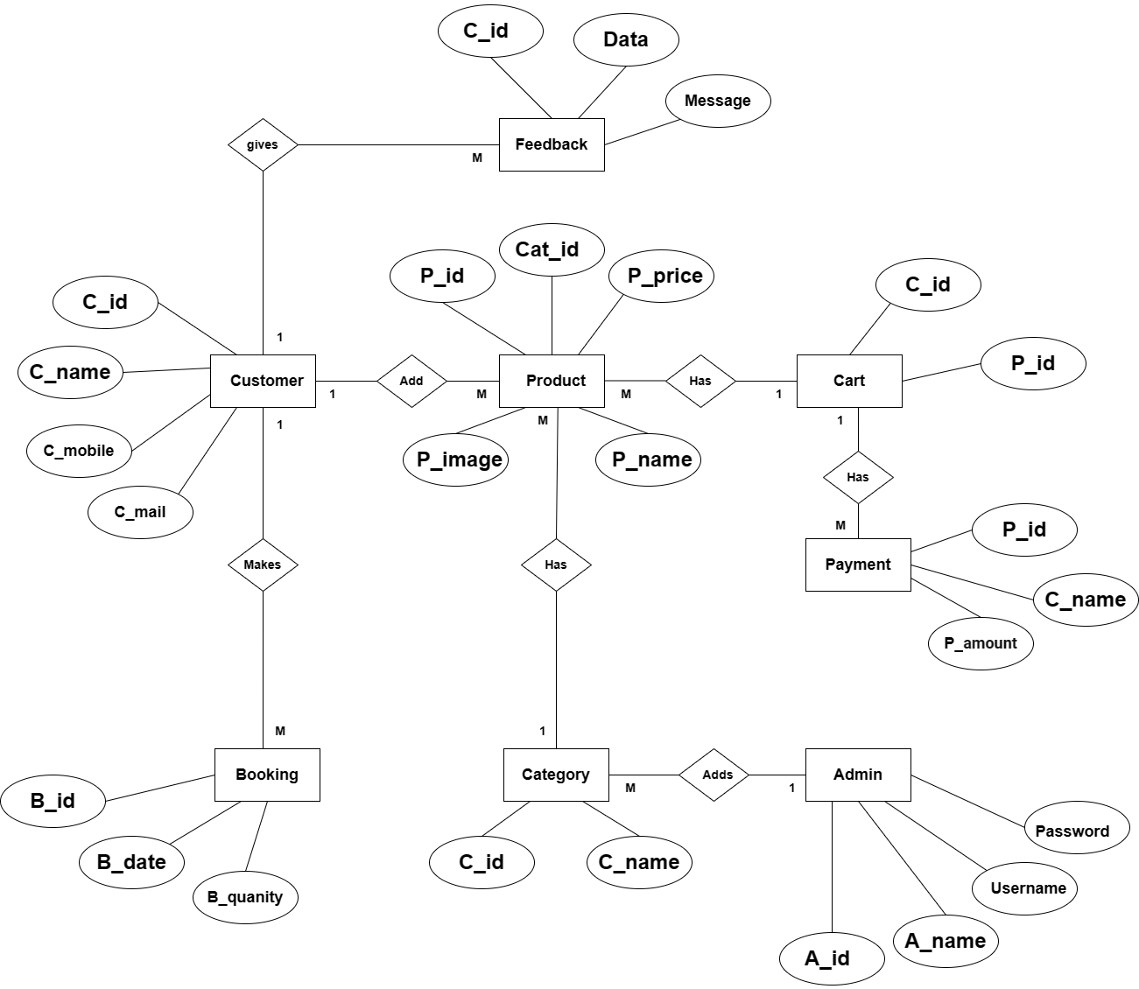

* 1. **Table Structure: -**

1. **Customer(login)**

|  |  |  |  |
| --- | --- | --- | --- |
| Name | Type | Null | Constraints |
| id | int(10) | No | Primary Key |
| UserName | varchar(30) | No | - |
| Password | varchar(128) | No | - |

1. **product**

|  |  |  |  |
| --- | --- | --- | --- |
| Name | Type | Null | Constraints |
| id | Int | No | Primary key |
| image | varchar(100) | No | - |
| name | varchar(30) | No | - |
| price | Int | No | - |
| desc | Text | No | - |
| category_id | Int | No | Foreign Key |

1. **category**

|  |  |  |  |
| --- | --- | --- | --- |
| Name | Type | Null | Constraints |
| id | Int | No | Primary key |
| name | varchar(30) | No | - |

1. **booking**

|  |  |  |  |
| --- | --- | --- | --- |
| Name | Type | Null | Constraints |
| Product id | Int | No | Foreign Key |
| book | varchar(30) | No | - |
| total | Int | Yes | - |
| booking_id | varchar(20) | Yes | Primary key |
| profile_id | Integer | Yes | Foreign Key |
| quality | varchar(100) | No | - |
| status_id | Integer | No | - |

1. **cart**

|  |  |  |  |
| --- | --- | --- | --- |
| Name | Type | Null | Constraints |
| id | Int | No | Primary key |
| product_id | Int | Yes | Foreign Key |
| profile_id | Int | Yes | Foreign Key |

1. **profile(customer registration)**

|  |  |  |  |
| --- | --- | --- | --- |
| Name | Type | Null | Constraints |
| id | Int | No | Primary key |
| password | varchar(128) | Yes | - |
| username | varchar(50) | Yes | - |
| last_name | varchar(50) | Yes | - |
| email | varchar(50) | Yes | - |
| first_name | varchar(50) | Yes | - |

1. **feedback**

|  |  |  |  |
| --- | --- | --- | --- |
| Name | Type | Null | Constraints |
| Id | Int | No | Primary key |
| Message | Text | No | - |
| Date | varchar(30) | No | - |
| profile_id | Int | No | Foreign Key |

# Use Case Diagram: -

# 

* 1. **Class Diagram: -**

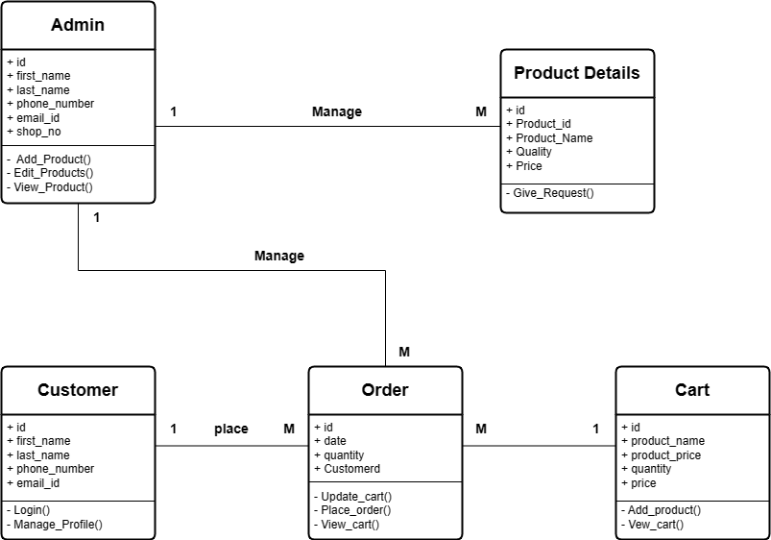

# Activity Diagram: -

1. Order Management Customer Side:

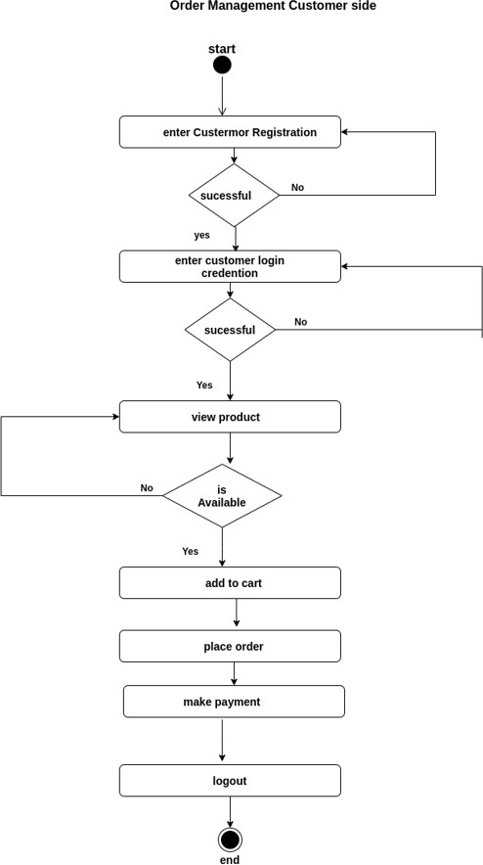

* 1. **Product Management :-**

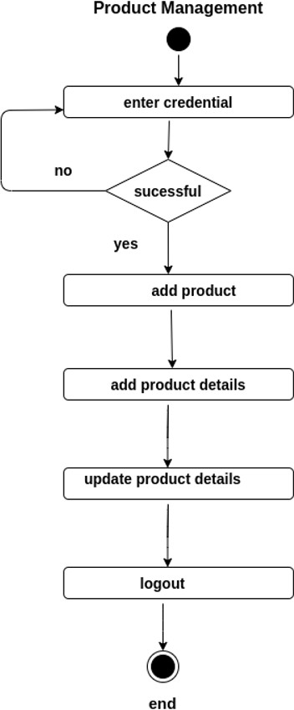

# Order Management Admin side:

# 

# Deployment Diagram: -

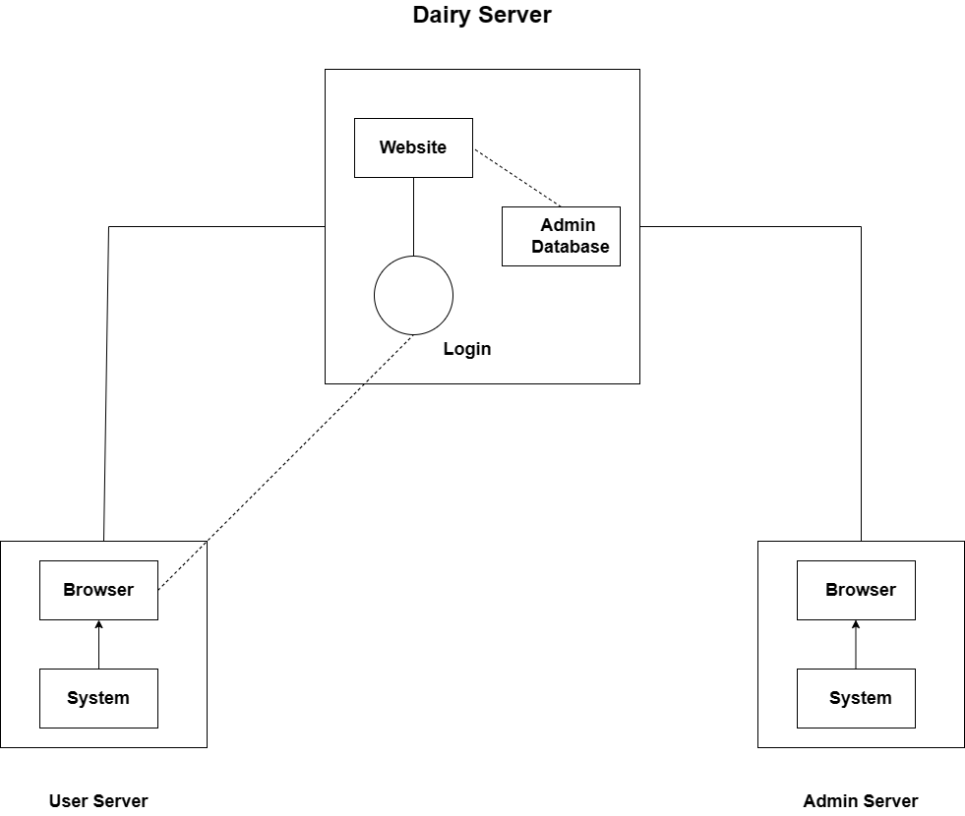

* 1. **Module Hierarchy Diagram: -**

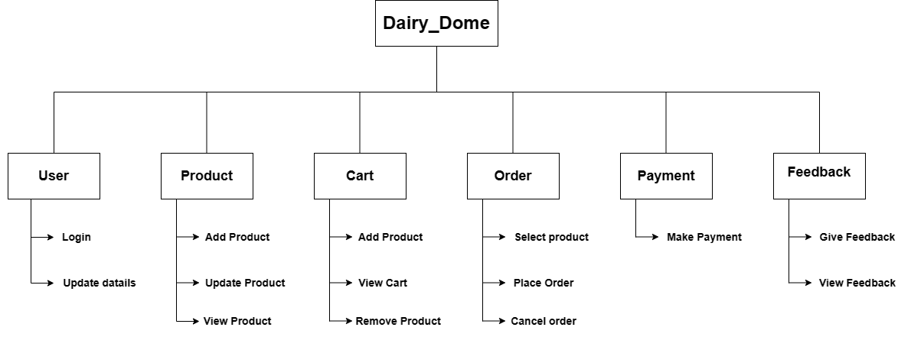

* 1. **Sample Input and Output Screens:-**

# Screens: - Sample Input

# Admin Side Screen:-

* **Login Page:-**

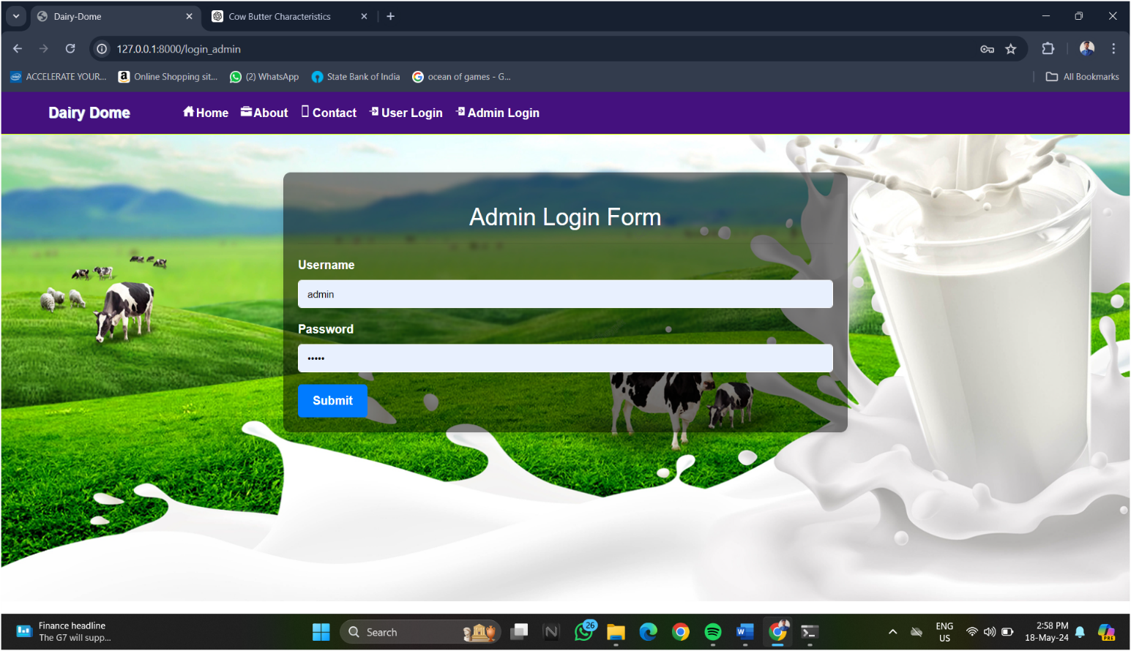

* **Home Page:-**

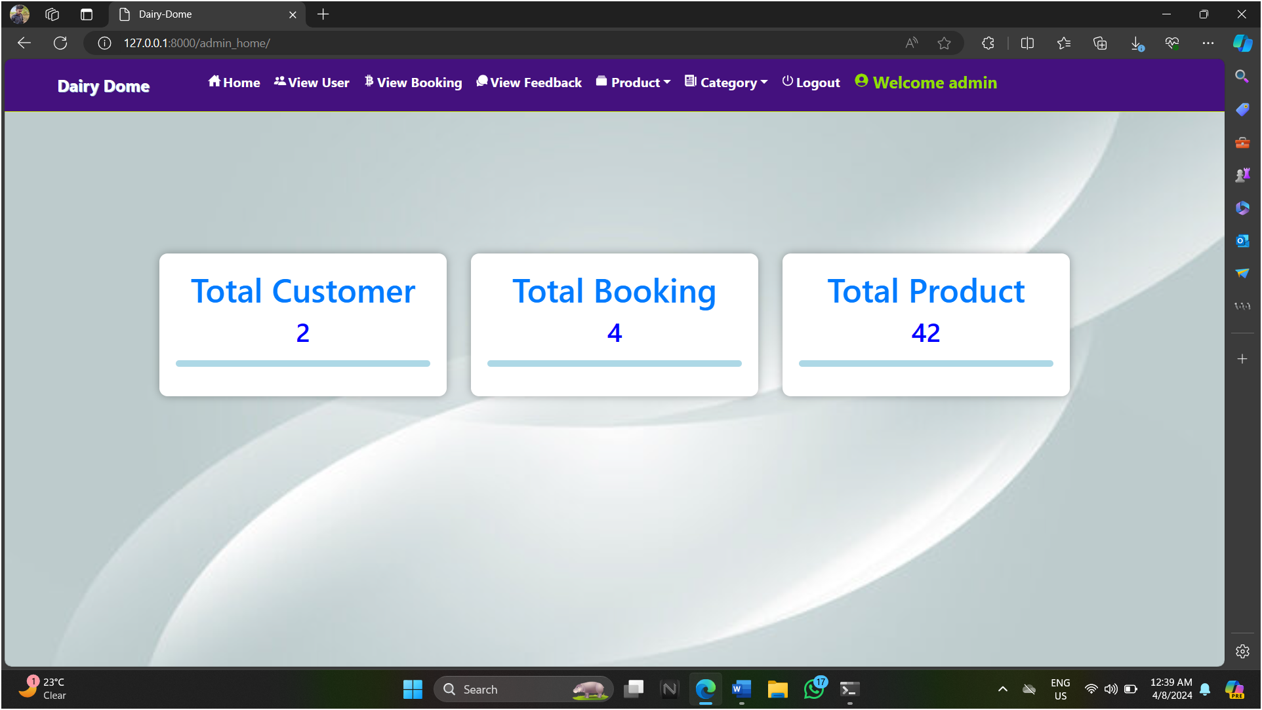

* **View User:-**

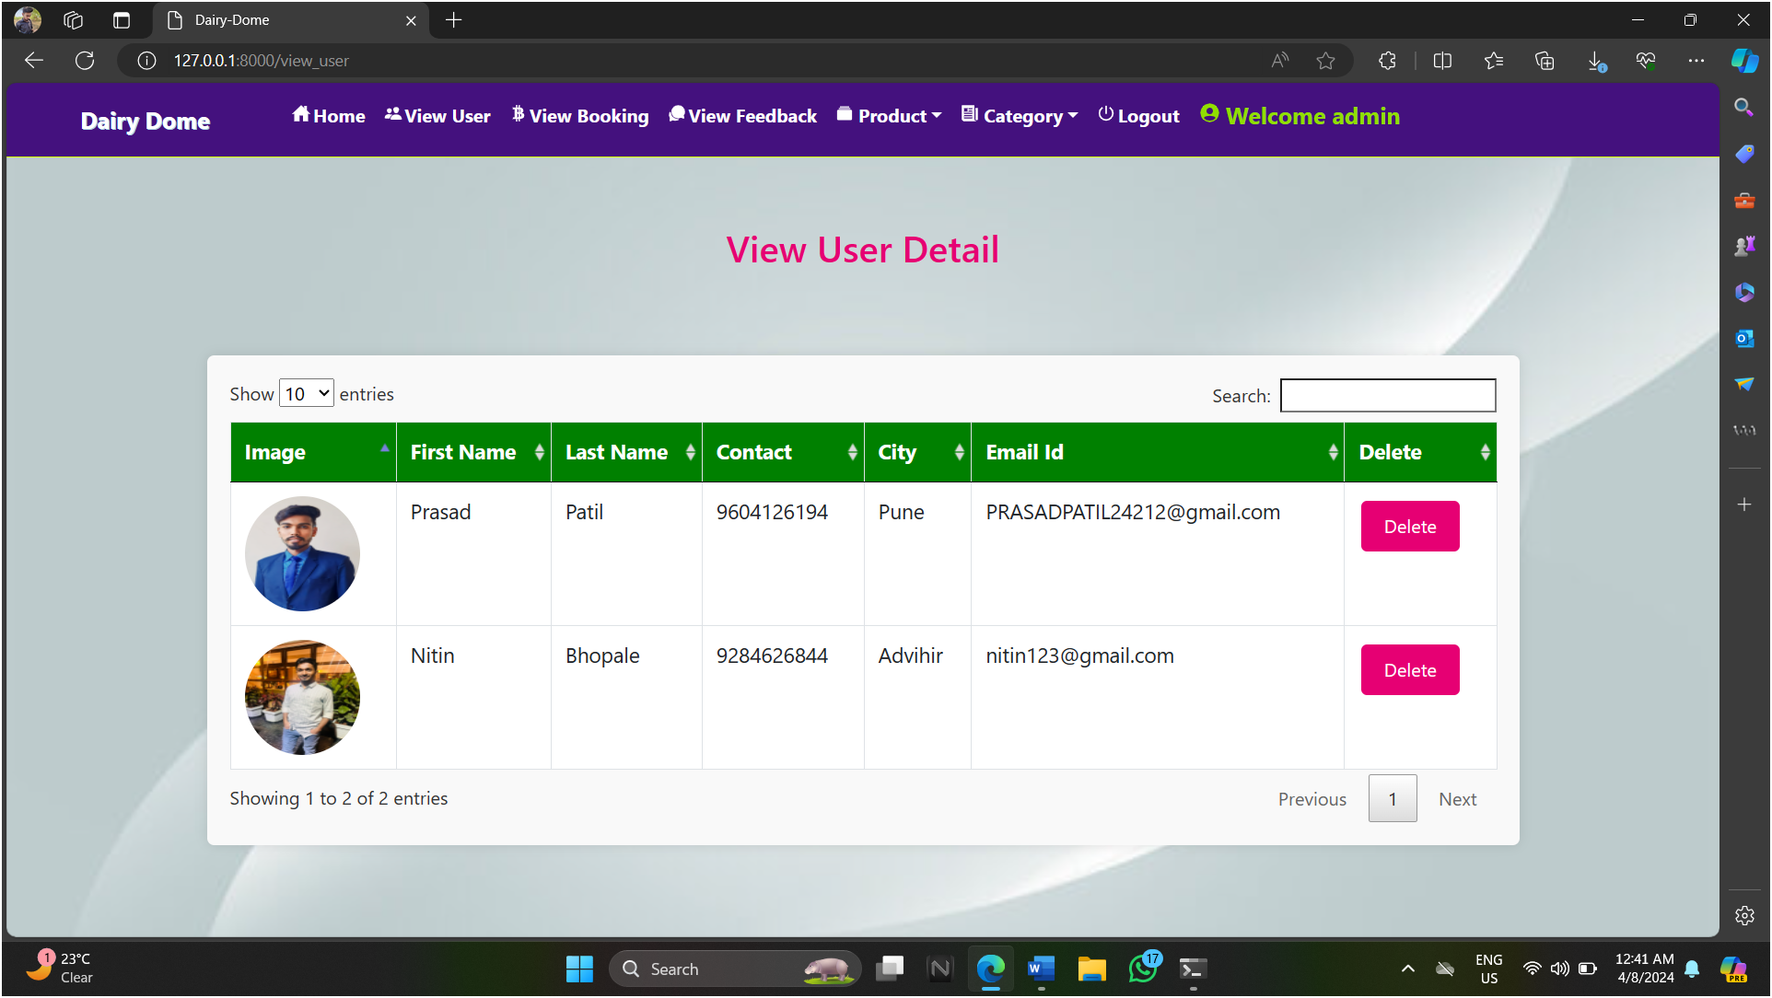

* **View Booking:-**

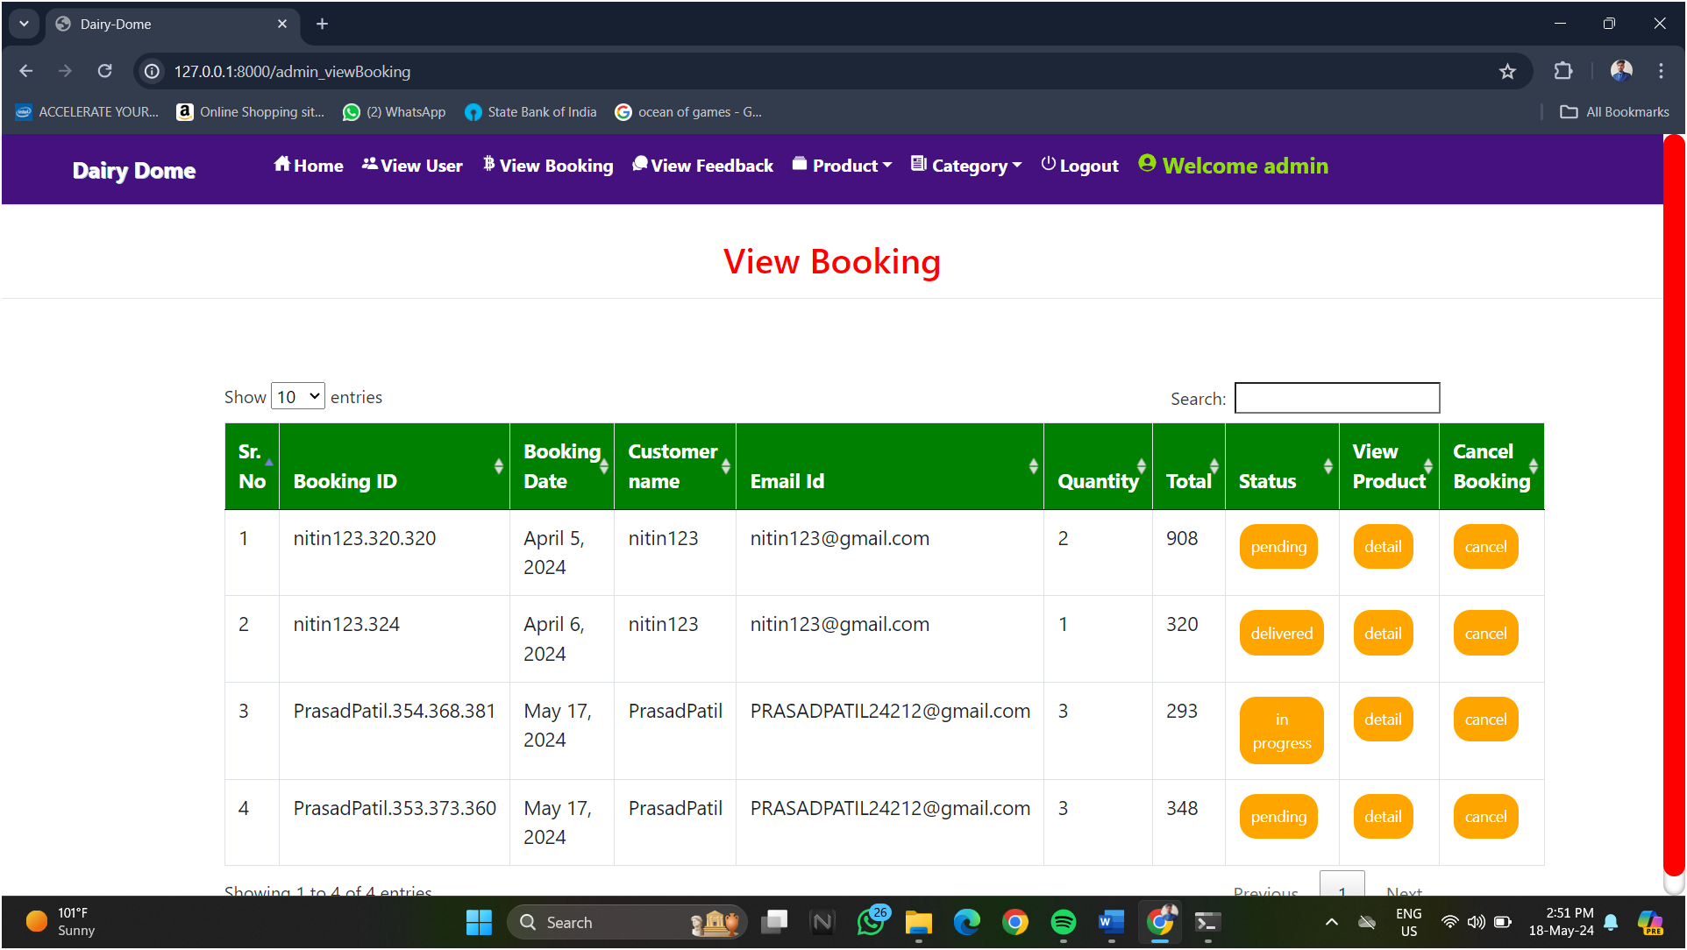

* **View Feedback:-**

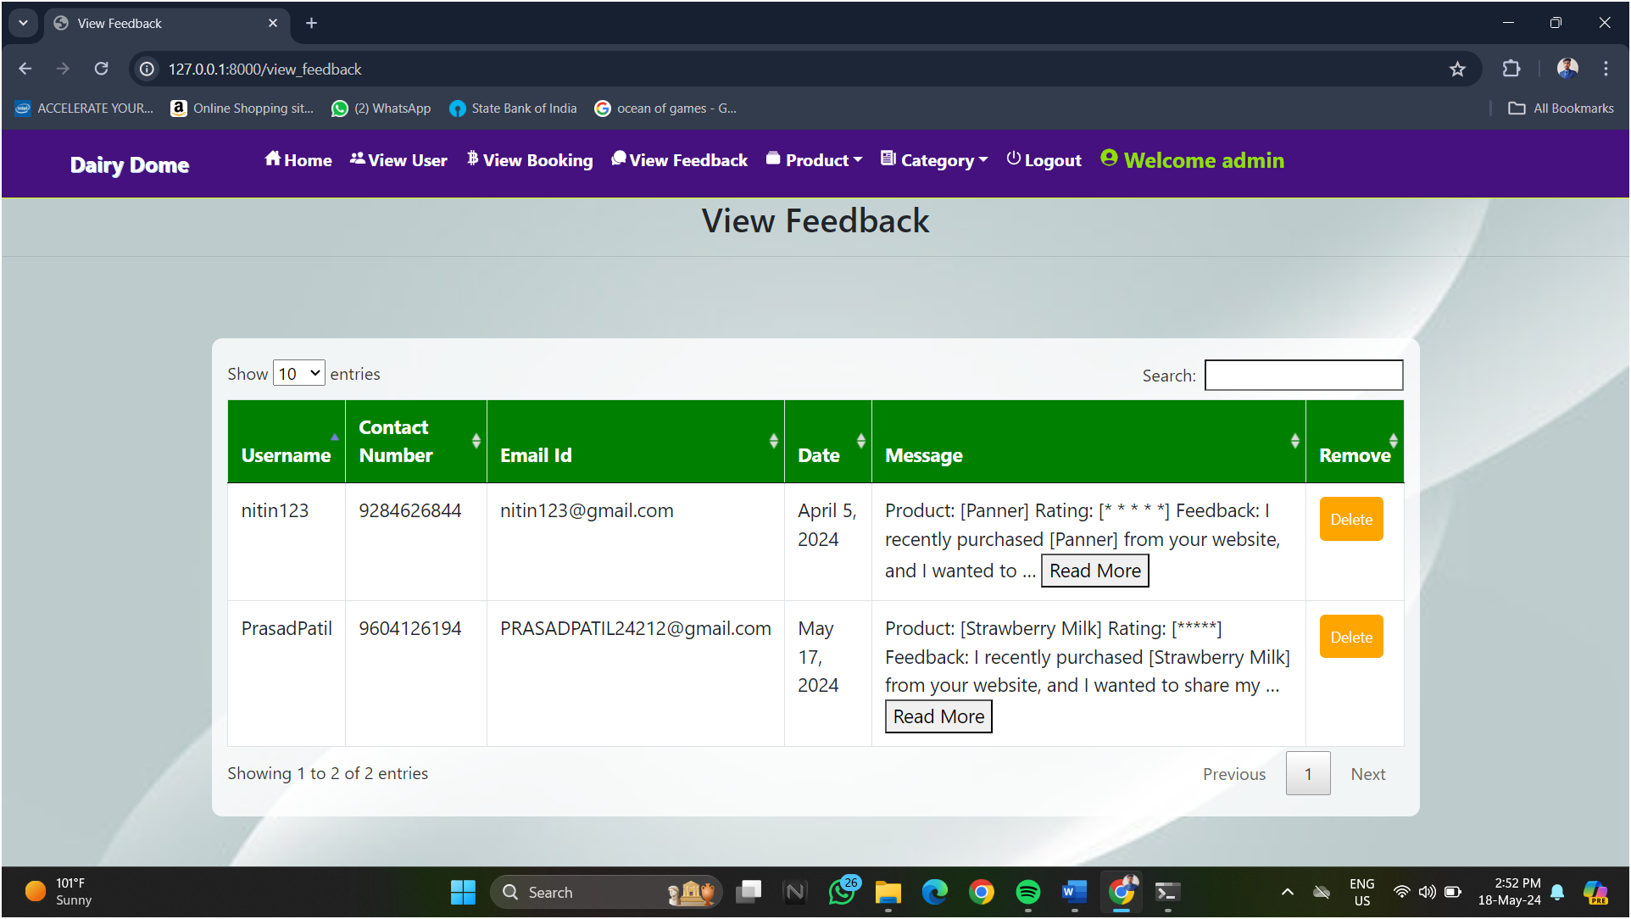

* **Add Product:-**

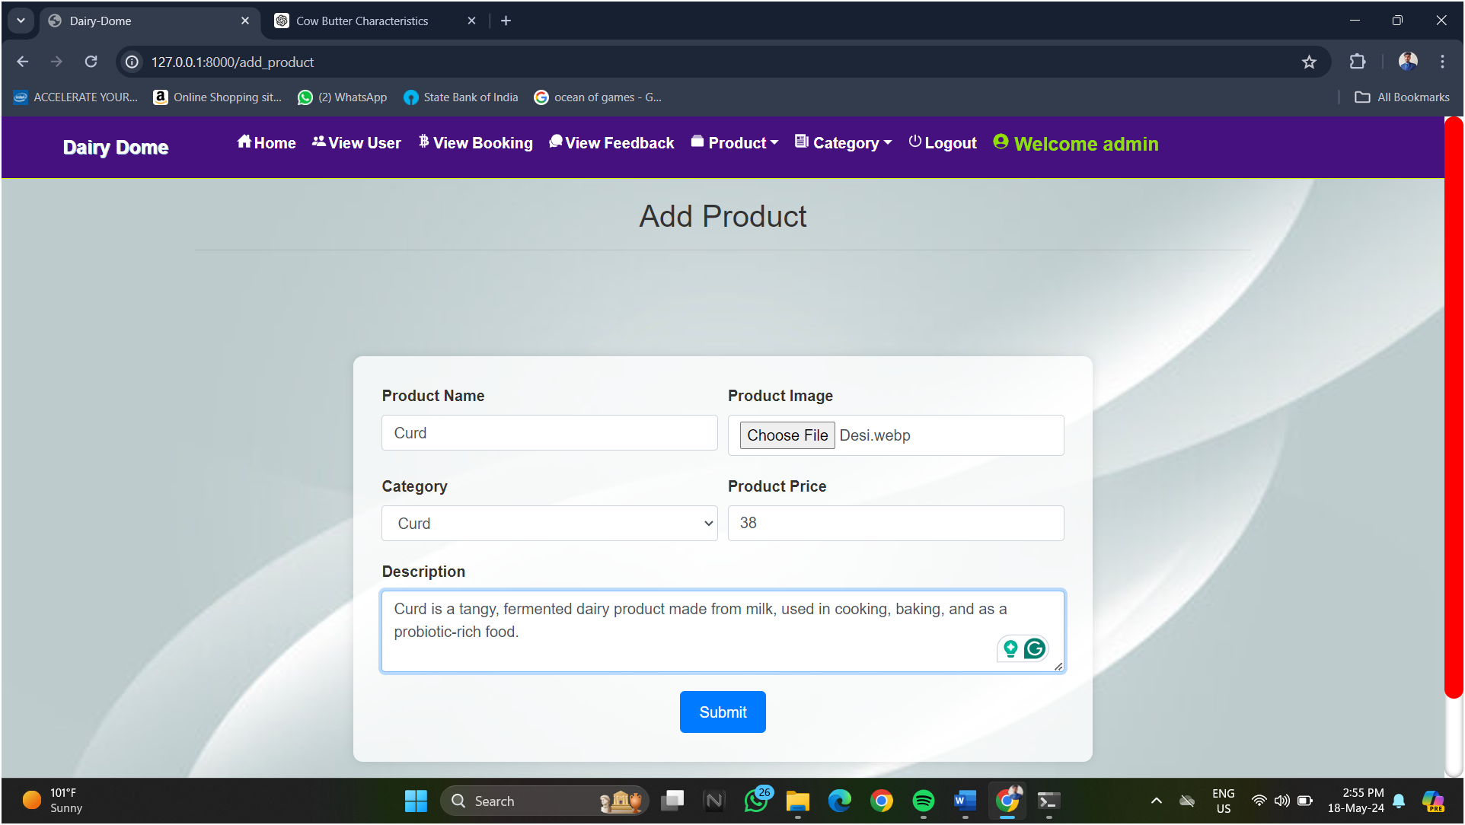

* **View Product:-**

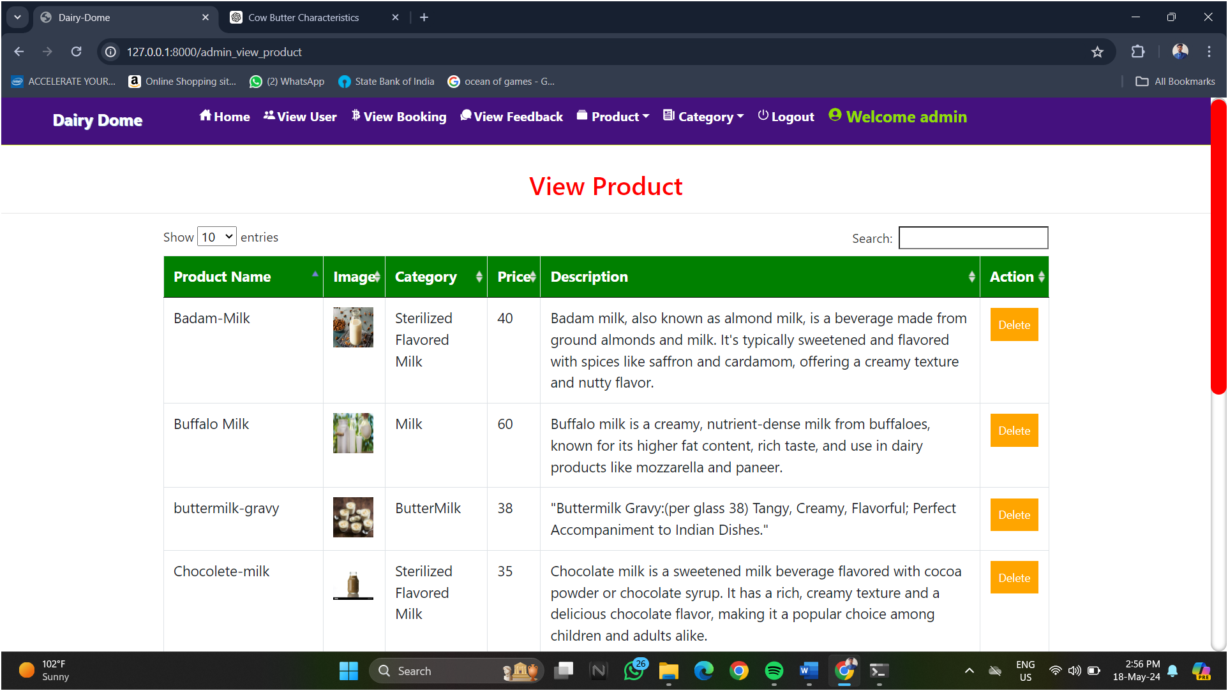

* **Add Category:-**

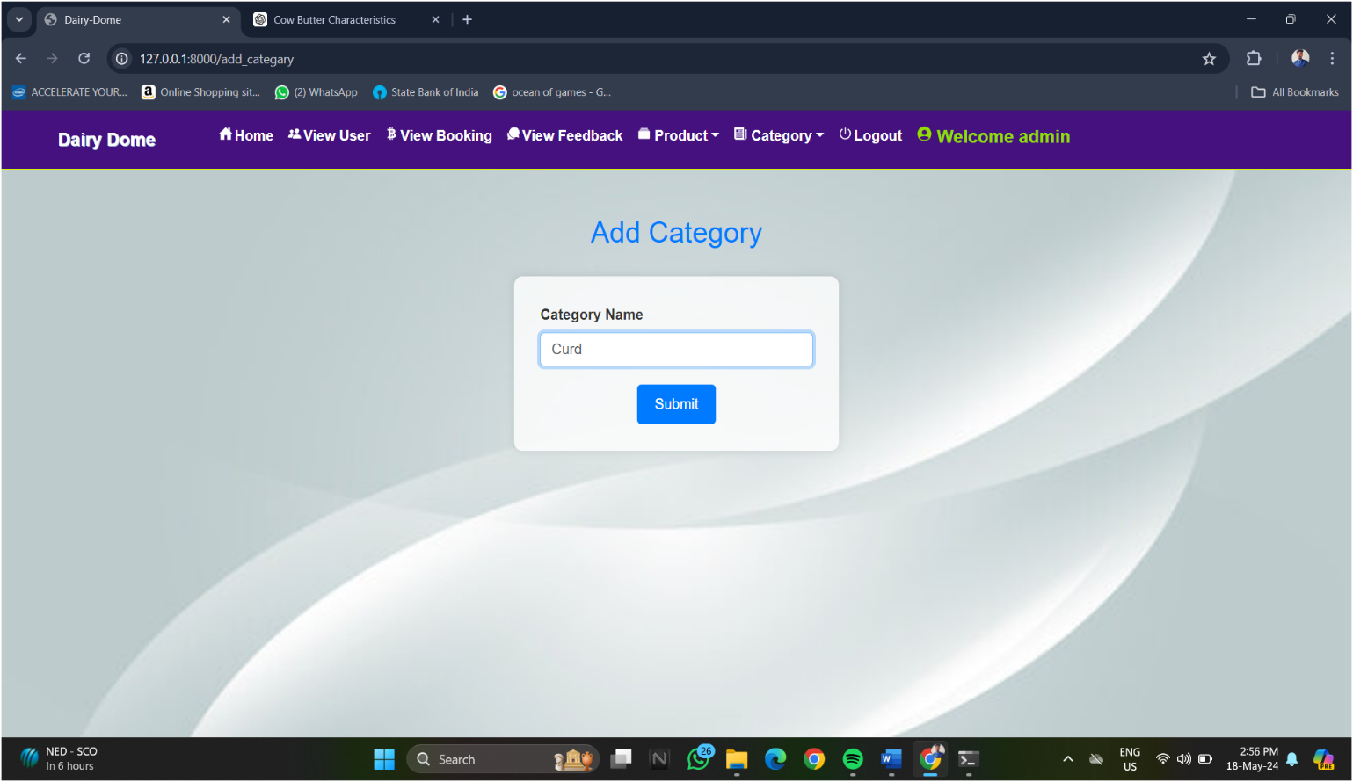

* 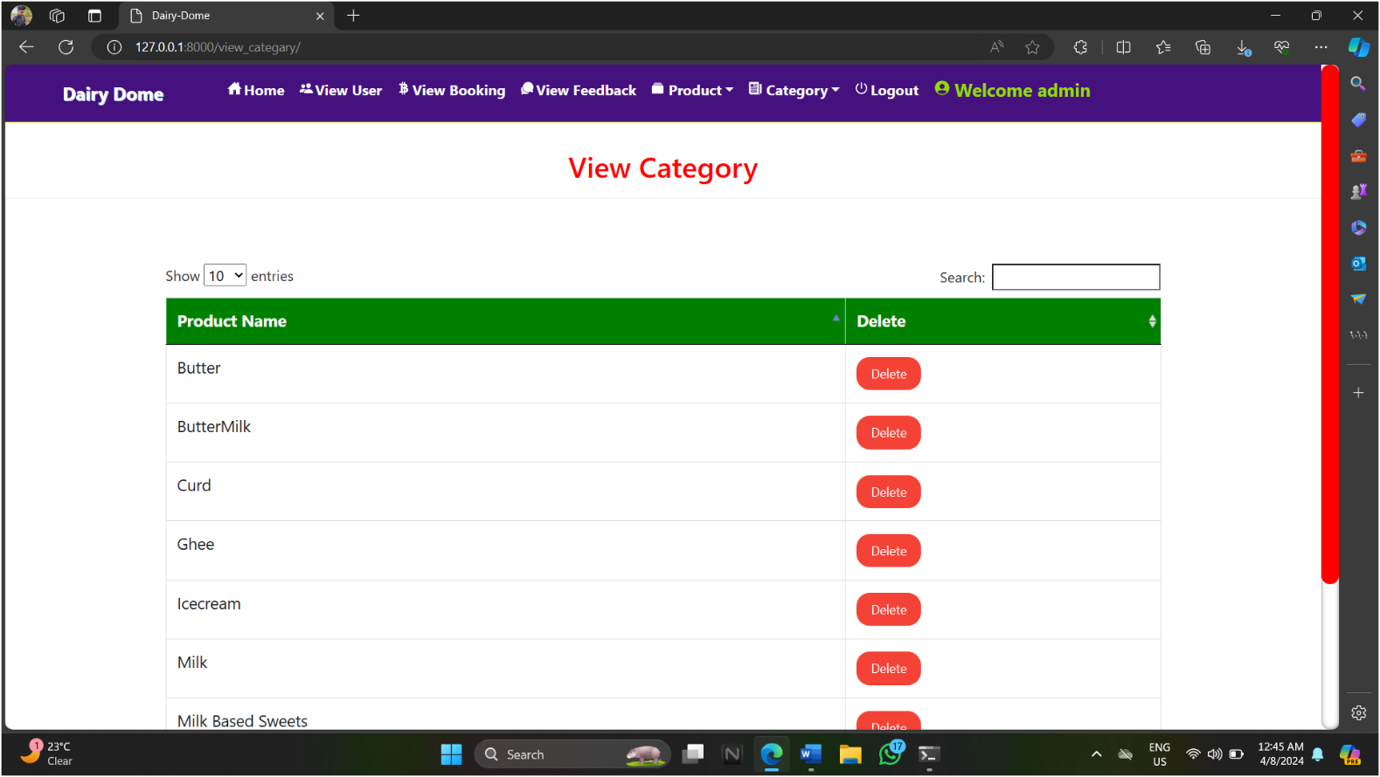**View Catrgory:-**
* **User Side Screen:-**
* **User Login Page:-**

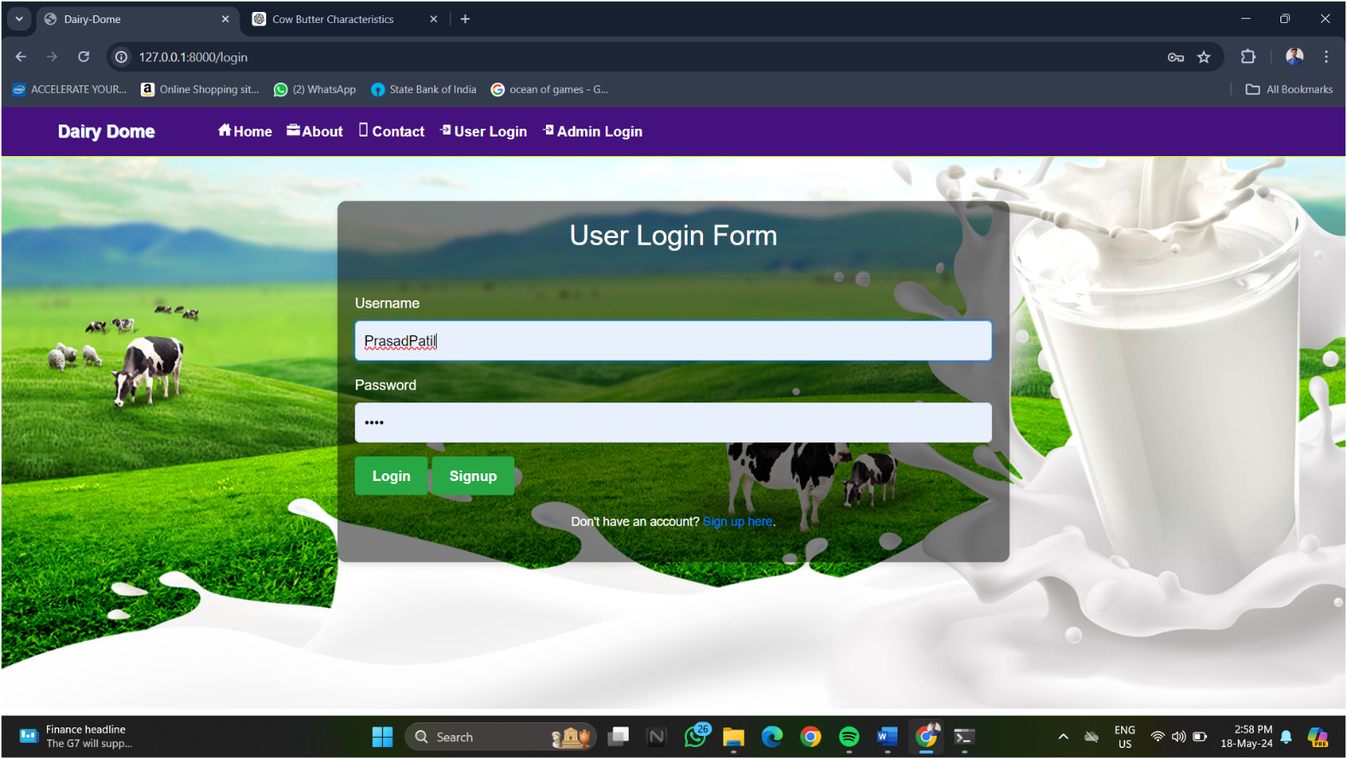

* **User Sign-Up Page:-**

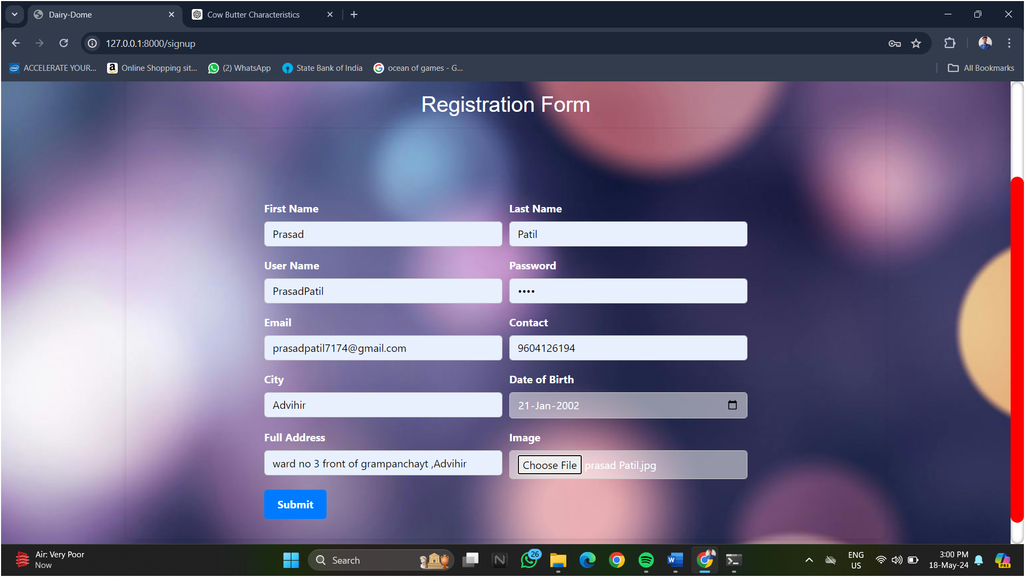

* 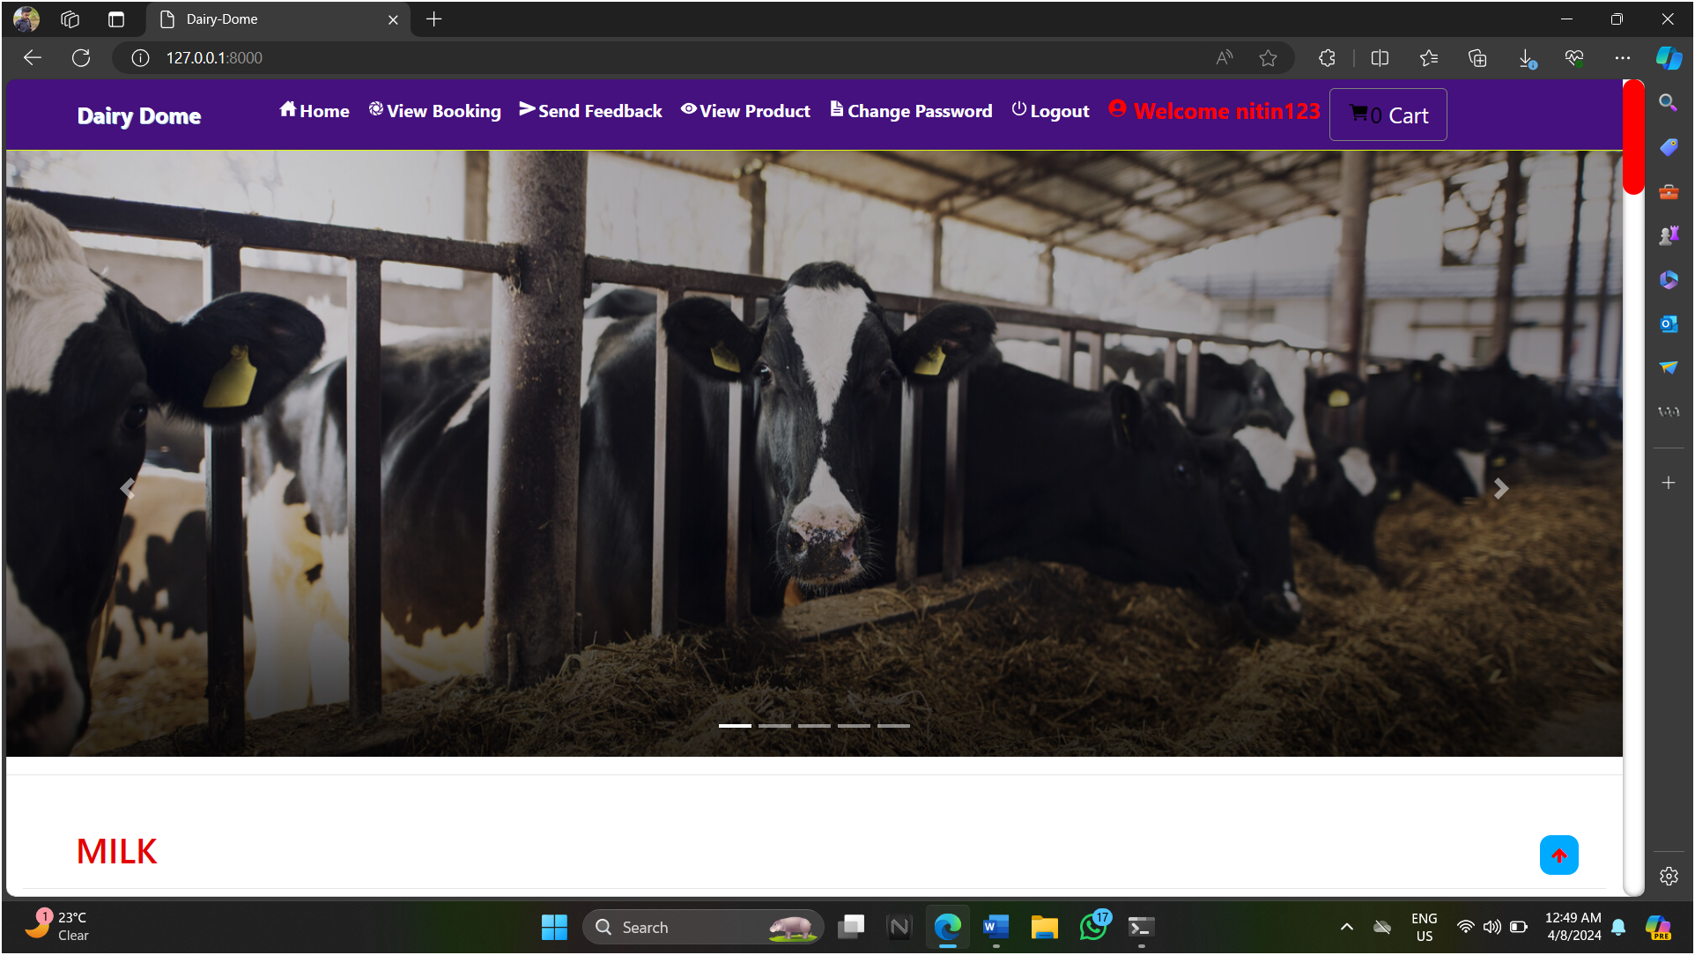**Home page:-**
* 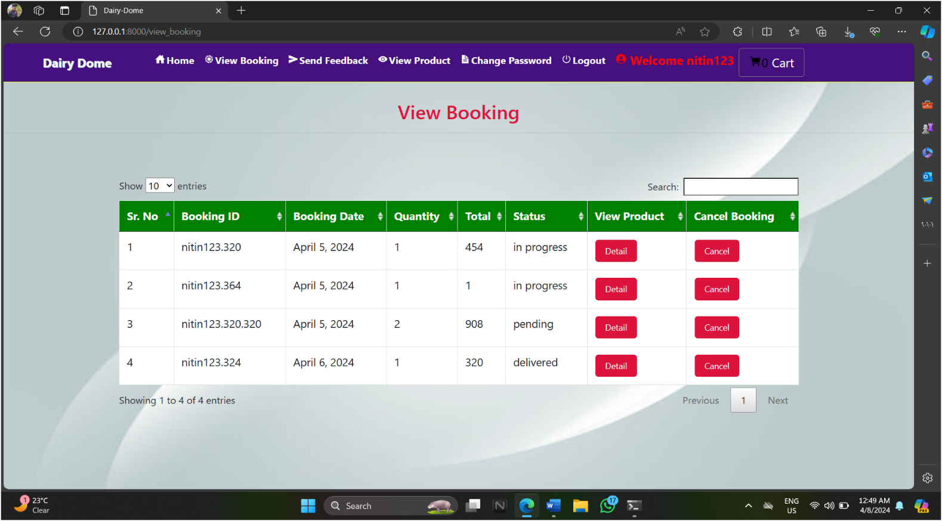**View Booking:-**

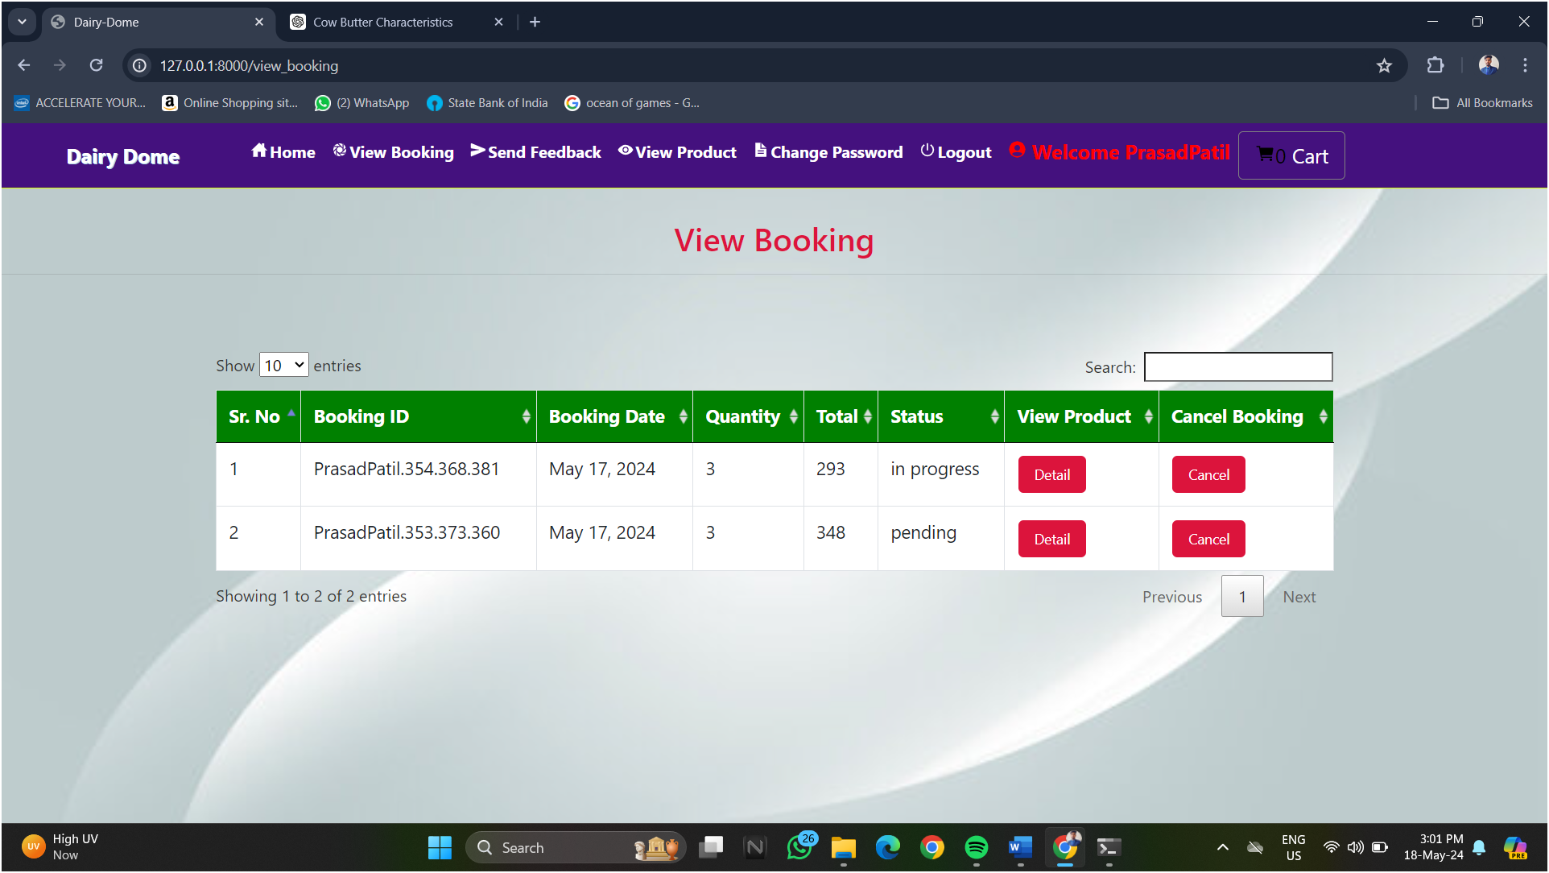

* **Send Feedback:-**

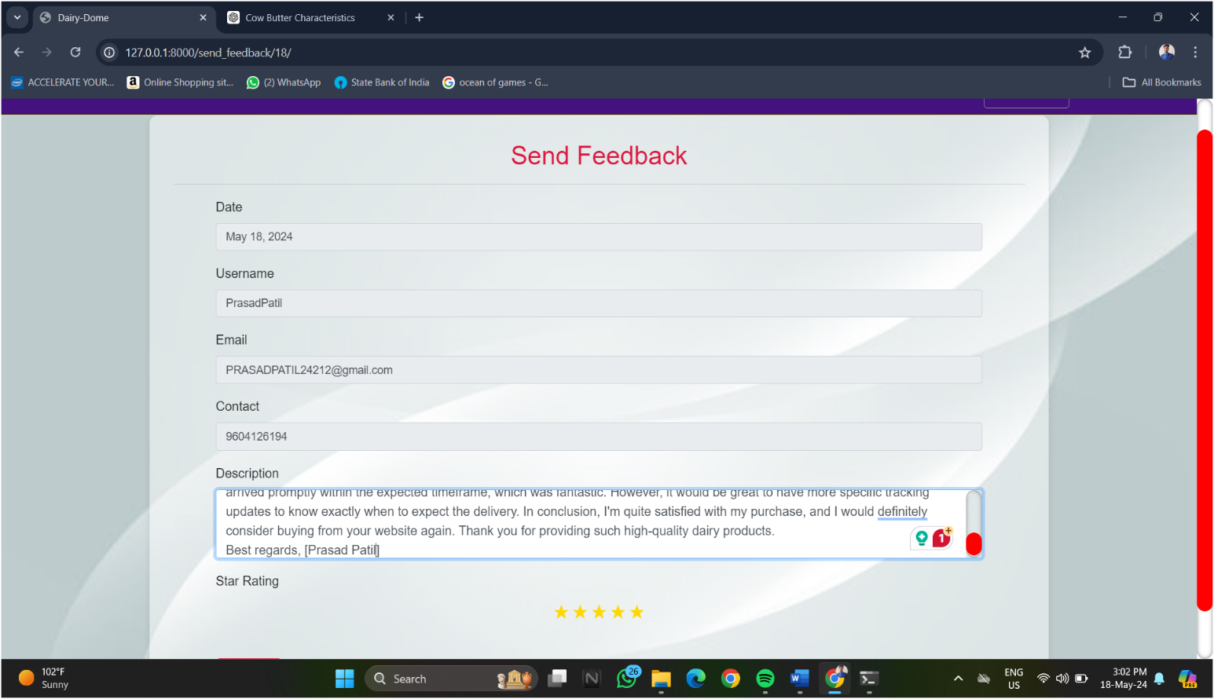

* **View Product:-**

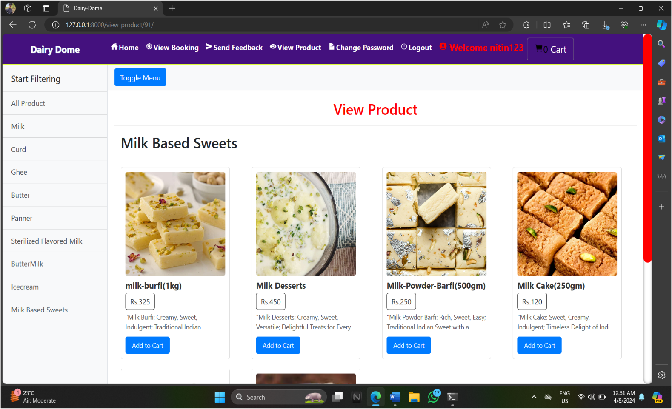

* **Change Password:-**

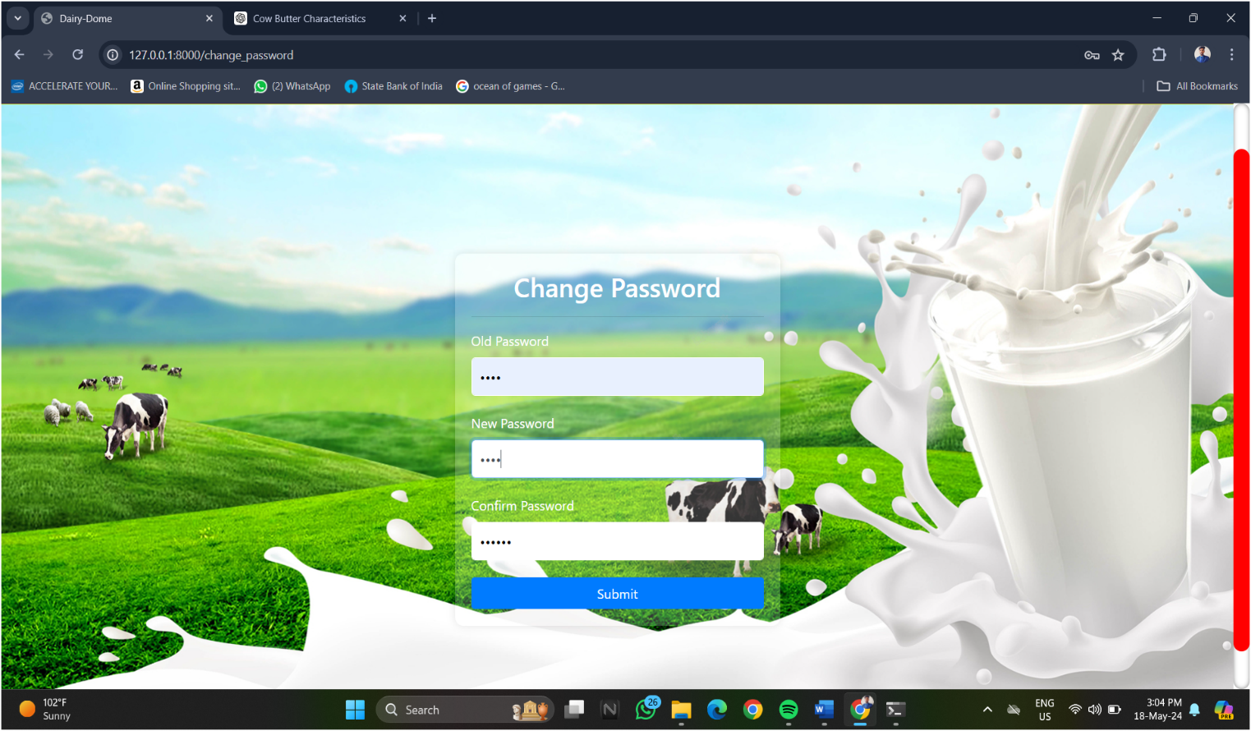

* 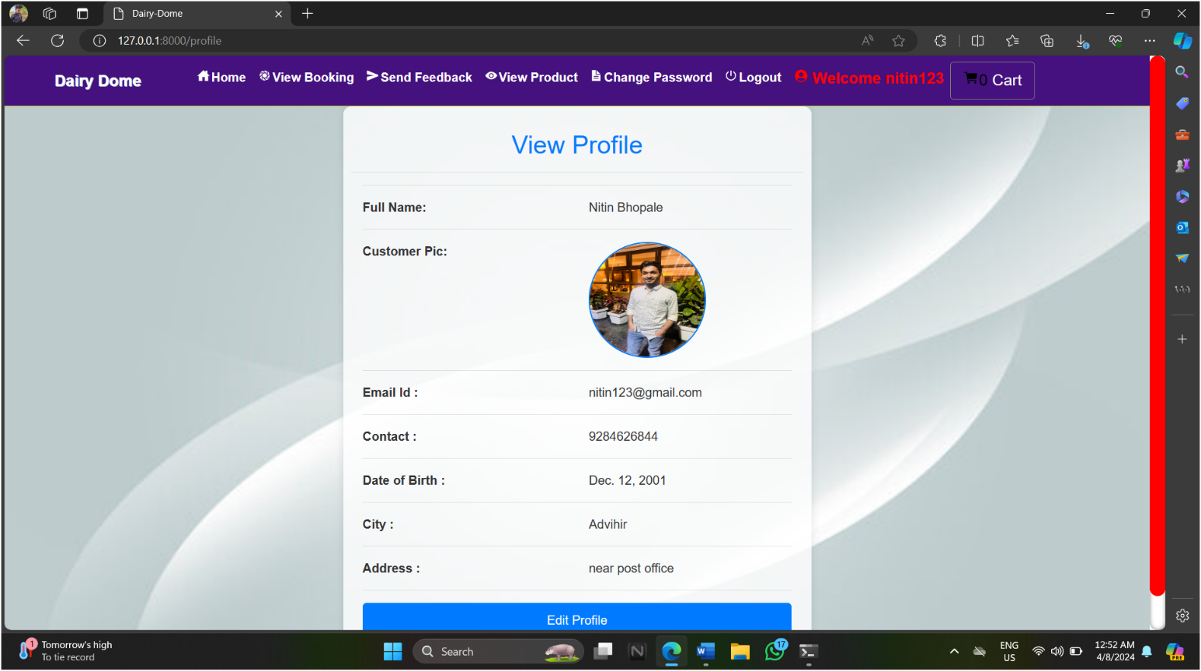**View Profile:-**

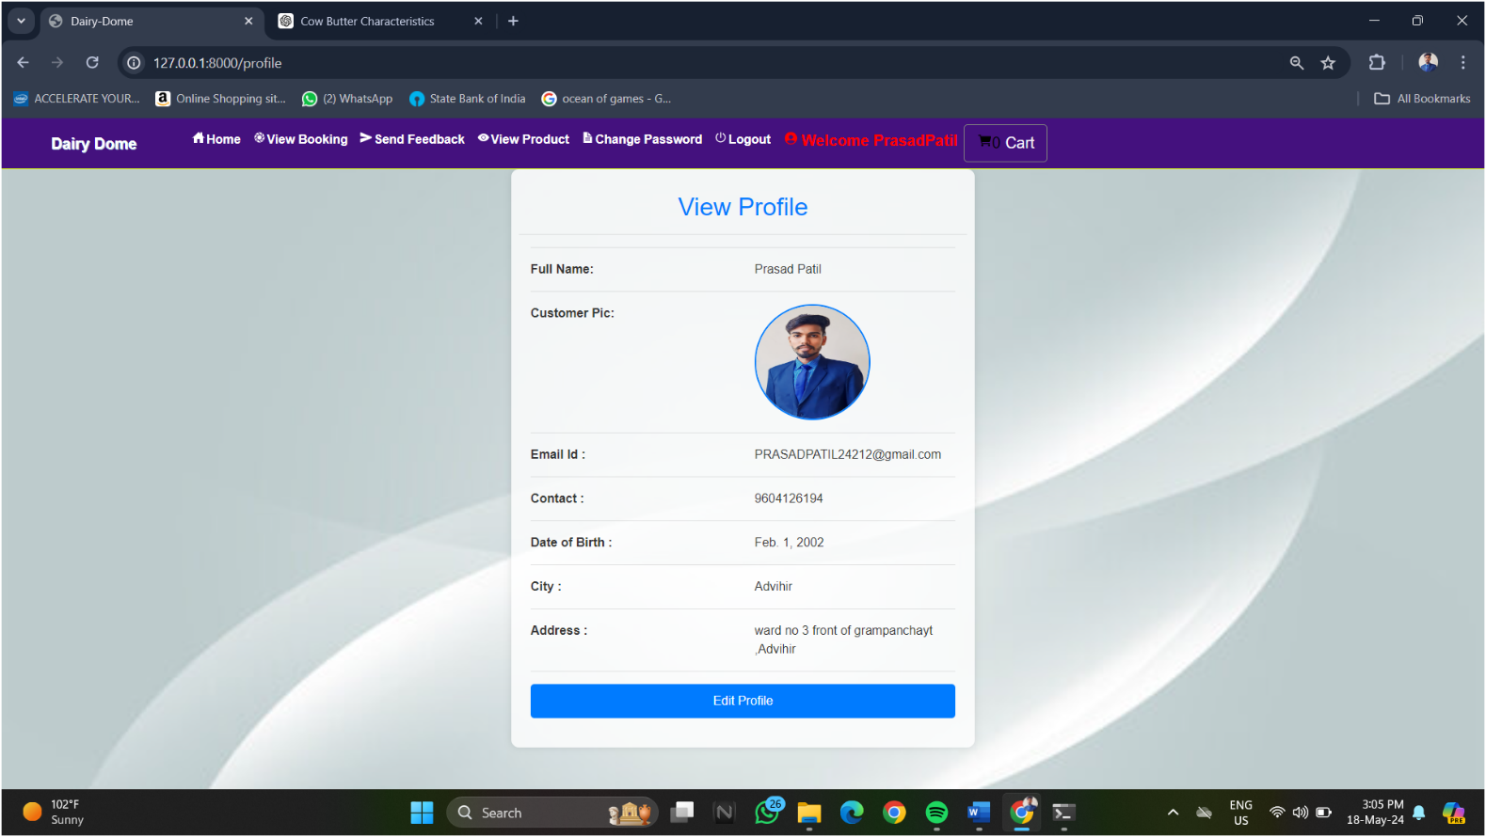

* 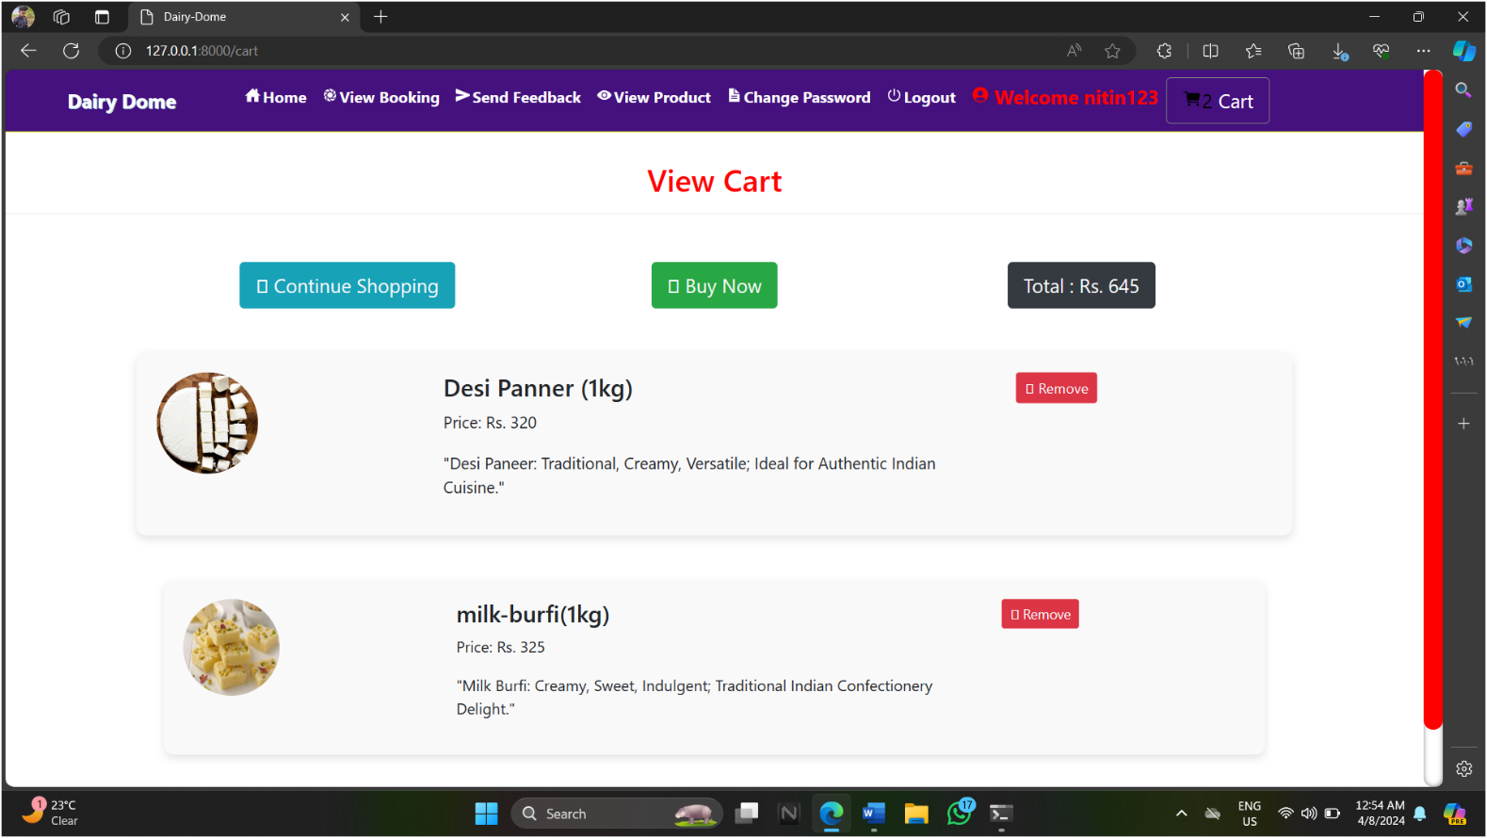**Cart Page:-**
* **Confirm Booking Detail :-**

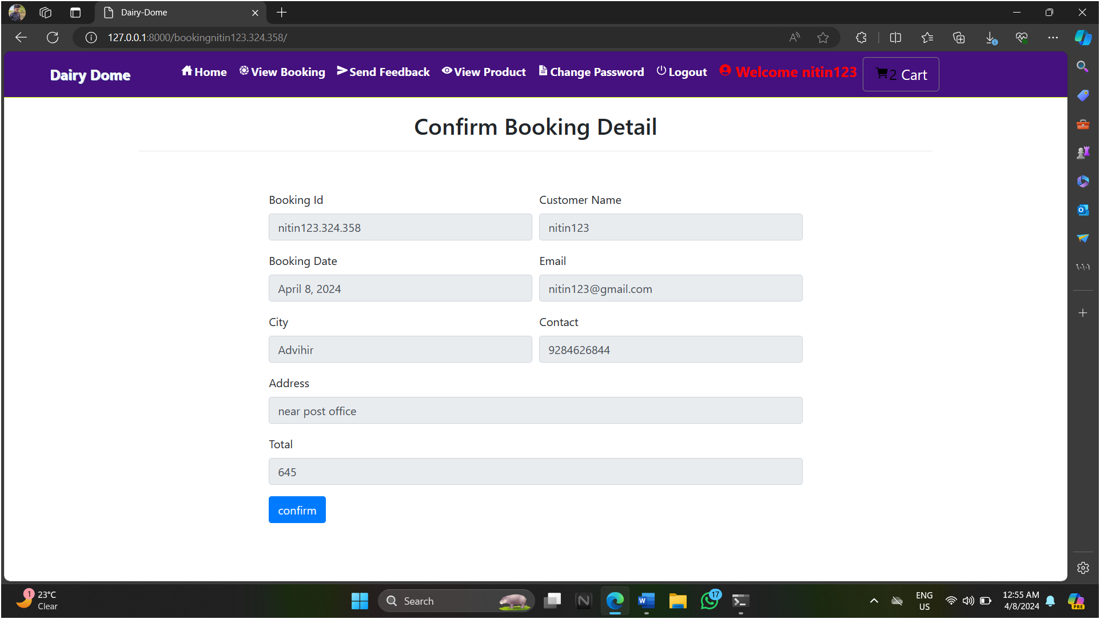

* **PAYMENT DETAIL :-**

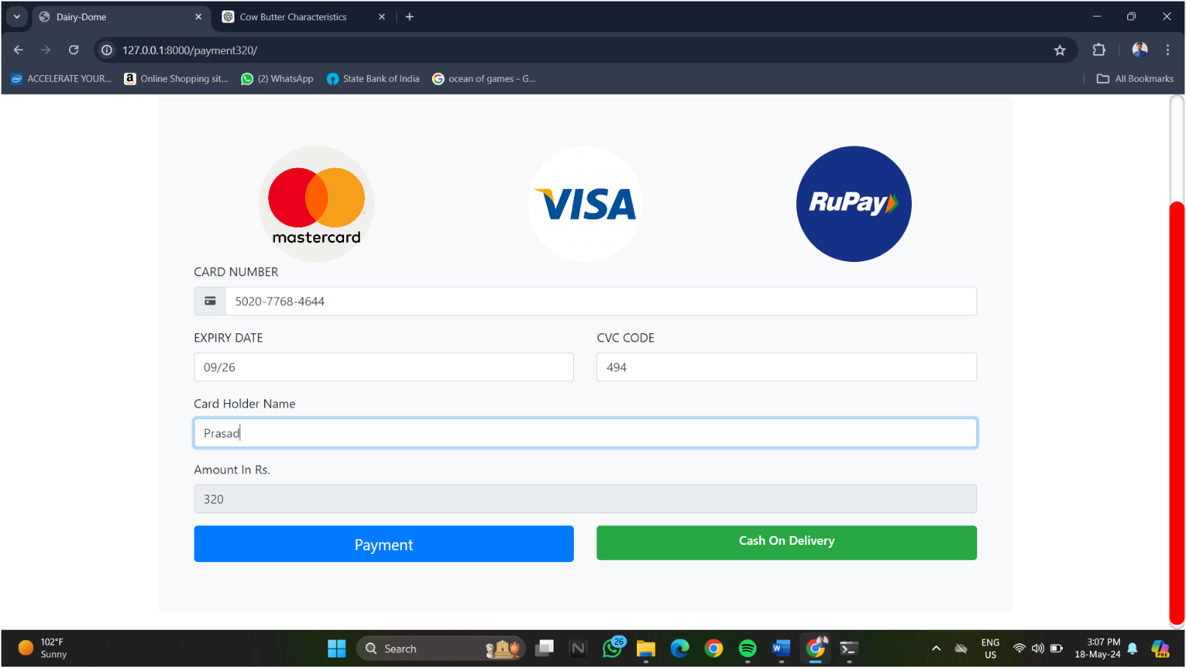

# Chapter 4. Coding

**Code Snippets:**

{% extends 'navigation.html' %}

{% block body %}

{% load static %}

{% ifequal error "yes" %}

<script>

alert('logged in successfully'); window.location="{% url 'home' %}";

</script>

{% endifequal %}

{% ifequal error "not" %}

<script>

alert('Username & Password are not Matching');

</script>

{% endifequal %}

<!DOCTYPE html>

<head>

<style>

.mybtnone:hover{

background-color : #E40203;

}

.form-group{

color: wheat;

}

.form{

padding: 20px;

}

</style>

<link rel="stylesheet" type="text/css" href="{% static 'css/util.css' %}">

<link rel="stylesheet" type="text/css" href="{% static 'css/main1.css' %}">

</head>

<div class="limiter">

<div class="container-login100" style="background-image: url('/media/milk.jpg'); ">

<div class="wrap-login100 p-t-30 p-b-50">

<div class="container">

<span class="login100-form-title p-b-41"> User Login

</span>

<div class="container-fluid">

<form class="form" method="post" action="">

{% csrf_token %}

<div class="form-group">

<label for="exampleInputEmail1">Username</label>

<input type="text" class="form-control" id="exampleInputEmail1" aria-describedby="emailHelp" name="uname" placeholder="Enter Username">

</div>

<div class="form-group">

<label for="exampleInputPassword1">Password</label>

<input type="password" class="form-control" id="exampleInputPassword1" placeholder="Password" name="pwd">

</div>

<button type="submit" class="btn btn-primary mybtnone">Login</button>

<button class="btn btn-primary mybtnone"><a href="{% url 'signup' %}" style="color:white">Signup</a></button>

</form>

</div>

</div>

</div>

</div>

</div>

{% endblock %}

</html>

<!-- <div class="container">

<h2 style="margin-top:20px" align="center">User Login Form</h2><hr>

<div class="container-fluid" style="width:70%;margin-top:10%">

<form method="post" action="">

{% csrf_token %}

<div class="form-group">

<label for="exampleInputEmail1">Username</label>

<input type="text" class="form-control" id="exampleInputEmail1" aria-describedby="emailHelp" name="uname" placeholder="Enter Username">

</div>

<div class="form-group">

<label for="exampleInputPassword1">Password</label>

<input type="password" class="form-control" id="exampleInputPassword1" placeholder="Password" name="pwd">

</div>

<button type="submit" class="btn btn-primary mybtnone">Login</button>

<button class="btn btn-primary mybtnone"><a href="{% url 'signup' %}" style="color:white">Signup</a></button>

</form>

</div>

</div> -->

{% extends 'navigation.html' %}

{% load static %}

{% block body %}

<!DOCTYPE html>

<html style="font-size: 16px;" lang="en"><head>

<link rel="stylesheet" href="/ayurcare/static/css/nicepage.css" media="screen">

<link rel="stylesheet" href="Aboutus.css" media="screen">

<script class="u-script" type="text/javascript" src="/ayurcare/static/js/jquery.js" "="" defer=""></script>

<script class="u-script" type="text/javascript" src="/ayurcare/static/js/jquery.js" "="" defer=""></script>

<meta name="generator" content="Nicepage 4.15.8, nicepage.com">

<link id="u-theme-google-font" rel="stylesheet" href="https://fonts.googleapis.com/css?family=Roboto:100,100i,300,300i,400,400i,500,500i,700,700i, 900,900i|Open+Sans:300,300i,400,400i,500,500i,600,600i,700,700i,800,800i">

<link id="u-page-google-font" rel="stylesheet" href="https://fonts.googleapis.com/css?family=Cherry+Cream+Soda:400">

<style> body,html{

height: 100%;

}

.u-section-1{

background-image: url("/media/115408.jpg"); background-position: center;

height: 100%;

width: 100%;

color: rgb(9, 1, 1);

font-weight: 500;

}

.u-text-1{

padding-left: 650px;

}

.u-text-2{

padding-left: 650px;

}

</style>

</head>

<body class="u-body u-xl-mode" data-lang="en">

<header class="u-clearfix u-header u-header" id="sec-023e">

<div class="u-clearfix u-sheet u-sheet-1">

</div>

</header>

<section class="u-align-right u-clearfix u-image u-shading u-section-1" id="carousel_f9ca">

<div class="u-clearfix u-sheet u-sheet-1">

<h1 class="u-custom-font u-font-titillium-Web u-text u-text-palette-3-base u-title u-text-1">About Us</h1>

<p class="u-align-left u-custom-font u-text u-text-2">

<span style="font-size: 1.875rem;" id="text"> Hola folks!&nbsp;<br>It looks like you are here to know us better. DairyDome is a user friendly, easy to use website where&nbsp;<br>one can order dairy by just search products and fill up a simple products order form available on the website. Admin can see the product order request and deliver product.&nbsp;To use all these features you need to login first . So register fast and order products.

</span>

<br>&nbsp; &nbsp; &nbsp; &nbsp;&nbsp;

</p>

</div>

</section>

<section class="u-clearfix u-section-2" id="sec-8623">

<div class="u-clearfix u-sheet u-sheet-1"></div>

</section>

</body></html>

{% endblock %}

# Chapter 5. Testing

# Test Case Name: Registration Test Case ID: TC01_Registration

**Test Case Prerequisite: User must open the portal.**

|  |  |  |  |  |  |  |  |
| --- | --- | --- | --- | --- | --- | --- | --- |
| **Sr.**  **No** | **Test to be Performed** | | **Expected Result** | | **Actual Result** | **Test**  **Pass/Failed** | **Remark** |
| 1. | Do the registration | | Registration | | Registration | Pass |  |
|  | with empty fields. | | failed. Message | | failed. Message |  |
|  |  | | Should be display “Please | | shown“Please enter  username”. |  |
|  |  | | enter username”. | |  |  |
| 2. | Do the | registration | Registration | | Registration failed. Message shown “Username already registered”. | Pass |  |
|  | with | duplicate | failed. Message | |  |
|  | username. |  | Should be | |  |
|  |  |  | display | |  |
|  |  |  | “Username | |  |
|  |  |  | already | |  |
|  |  |  | registered”. | |  |
| 3. | Do the registration | | Registration | | Registration | Pass |  |
|  | with invalid email | | failed. Message | | failed. Message |  |
|  | address. | | Should be display“Invalid | | shown “Invalid email id”. |  |
|  |  | | email id”. | |  |  |
| 4. | Do the registration | | Registration | | Registration | Pass |  |
|  | with password | | failed. Message | | failed. Message |  |
|  | contained less than 8  characters | | Should be display  “Password | | shown “Password  should be |  |
|  |  | | Should be minimum of 6 | | minimum of 6  characters”. |  |
|  |  | | characters”. | |  |  |
| 5. | Enter valid mobile number. | | Registratin should  successful. | be | Registratin Successful. | Pass |  |
| 7. | Verify whether the user has leave empty field. | | Registration should be Failed. All fields are mandatory. | | Registration Failed. | Pass |  |

# Test Case Name: Login Test Case ID: TC02_Log_in

**Test Case Prerequisite: User must have visited the portal.**

# User must be registered.

|  |  |  |  |  |  |
| --- | --- | --- | --- | --- | --- |
| **Sr.**  **No** | **Test to be Performed** | **Expected Result** | **Actual Result** | **Test**  **Pass/Failed** | **Remark** |
| 1. | Check login with valid data | Login successful & should be open home Page | Login successful. Home page opened. | Pass |  |
| 2. | Check login with invalid data | Login failed. Message should be display “Username or  Password is invalid”. | Login failed. Message shown, “Username or Password is invalid”. | Pass |  |
| 3. | Check login with empty fields. | Login failed. Message should be display “Please enter username  & password”. | Login failed, Message shown “Please enter username  & password”. | Pass |  |
| 4. | Check whether username or password is case sensitive | Login failed, Message should be displayed “Username or  Password is invalid”. | Login failed message shown “Username or Password is invalid”. | Pass |  |

**Test Case Name:Order management Test Case ID: TC03_Order**

# Test Case Prerequisite: User must visit portal.

**User must be registered.**

**User must be Login.**

|  |  |  |  |  |  |
| --- | --- | --- | --- | --- | --- |
| **Sr.**  **No** | **Test to be Performed** | **Expected Result** | **Actual Result** | **Test**  **Pass/Failed** | **Remark** |
| 1. | Verify whether the customer is able to select product. | Product should be select from dropdown. | Product selected successfully from dropdown. | Pass |  |
| 2. | Check whether the customer has filled all the valid details. | All filled details should be valid. | All field details added successfully. | Pass |  |
| 4. | Check whether the customer has leave the empty fields. | On screen error message should be display “Please fill all the details”. | On screen error message is showing “Please fill all the details”. | Pass |  |
| 6 | Check whether the customer is able to add product to cart. | Cart should be updated . | Added product successfully. | Pass |  |
| 7 | Check whether the customer is able to delete existing cart product. | Record should be added and view to delete details. | Record deleted successfully. | Pass |  |

Test Case Name: Payment Management Test Case ID: TC04_Payment

**Test Case Prerequisite: User must launch the service application.**

# User must be registered. User must be Login.

|  |  |  |  |  |  |
| --- | --- | --- | --- | --- | --- |
| **Sr.**  **No** | **Test to be Performed** | **Expected Result** | **Actual Result** | **Test**  **Pass/Failed** | **Remark** |
| 1. | Select card type. | Card is selected. | Card selected  Successfully. | Pass |  |
| 2. | Enter card details | Only numeric values should be entered. | Only numeric values entered successfully. | Pass |  |
| 3. | Check weather payment details is valid. | All field details should be valid. | All field details added successfully. | Pass |  |

**Test Case Name: Feedback Test Case ID: TC05_feedback**

# Test Case Prerequisite: User must visit portal.

**User must be registered.**

**User must be Login.**

|  |  |  |  |  |  |
| --- | --- | --- | --- | --- | --- |
| **Sr.**  **No** | **Test to be Performed** | **Expected Result** | **Actual Result** | **Test**  **Pass/Failed** | **Remark** |
| 1. | Verify whether the user can give feedback . | After submitting feedback message should appear as successfully. | Feedback successfully. | Pass |  |
| 2. | Verify whether the user is able to enter a comments. | Comment should be entered successfully. | Comment entered successfully. | Pass |  |

# Limitations of Proposed System: -

* + It makes bug fixes little harder.
  + This system does not provide fully automotive process.
  + This website does not generate graphical reports therefore admin cannot understand reports.

# Proposed Enhancement: -

* User will get the receipt of the payment.
* Will also add maps to locate stores for nearby areas .

# Conclusion: -

The system will be able to serve as web application when it is finally developed, where these small upcoming shops can make use of it to publish different categories of Dairy products in a wide range and also help the shop to manage their service more effectively. On the other hand, it will enable customers to freely buy their required type of product more freely and interactively.

# Bibliography: -

**For python**

* https:/[/www](http://www.w3schools.com/python/default.asp).[w3schools.com/python/default.asp](http://www.w3schools.com/python/default.asp)
* https:/[/www](http://www.sitepoint.com/).[sitepoint.com/](http://www.sitepoint.com/) python /
* https:/[/www](http://www/). python.net/

**For MySQLite**

* https:/[/www](http://www.mysqlite.com/).[mysqlite.com/](http://www.mysqlite.com/)
* [http://www.mysqlitetutorial.org](http://www.mysqlitetutorial.org/)

1. **User Manual (All GUI screens with validation description etc.)**

# User Manual Screens: -

# 

* + This page is the user login page where user will login.
  + Validations are applied for all the text inputs
* **Home Page:**
* This is the home page where we can view the options .
* Validations are applied for all the text inputs
* **View Booking:**

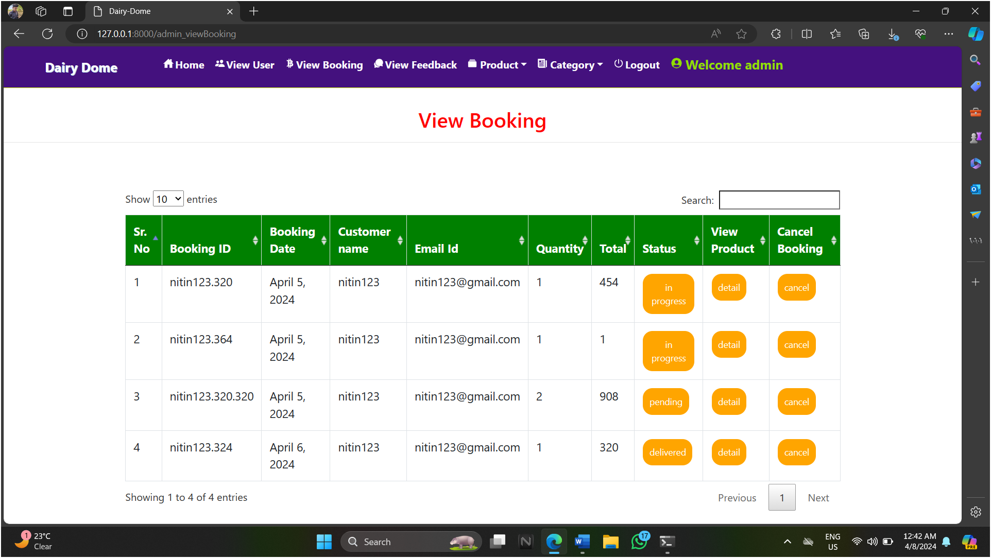

* Details are viewed .

* **Feedback:-**

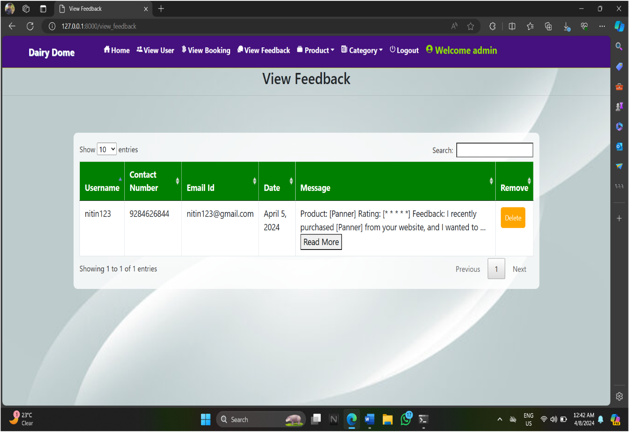

* In this page, we will get feedback.
* **View Products:**

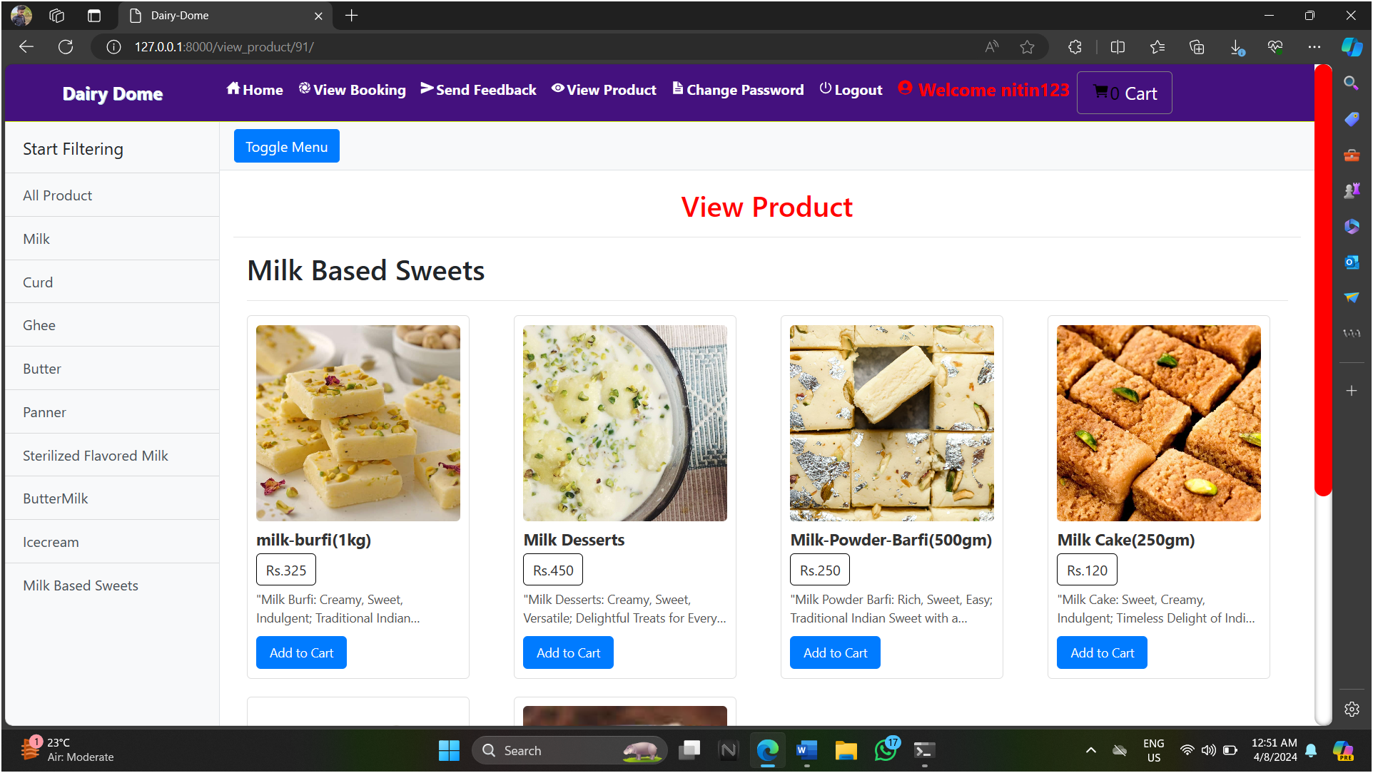

* In this page, We can view products.
* **View Cart**

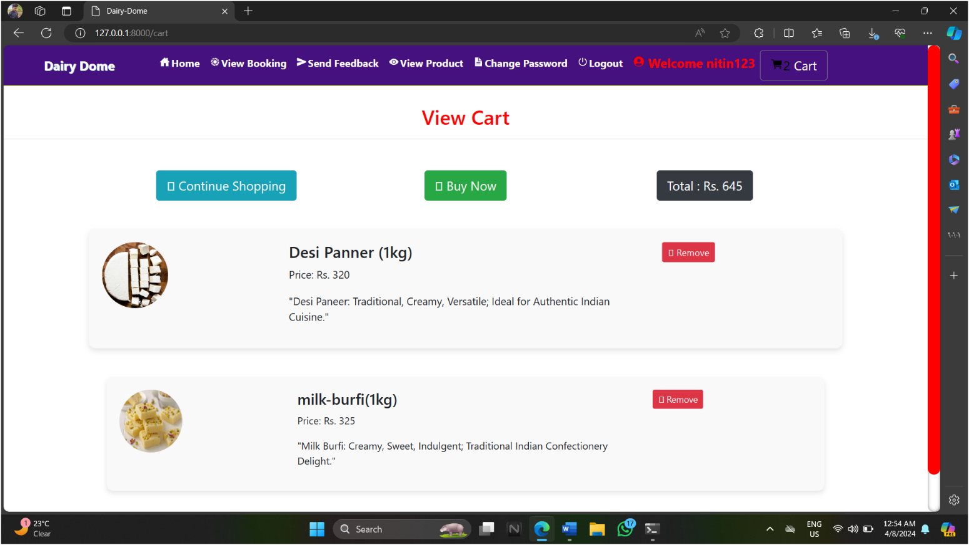

* In this page, We can View Cart.
* **Confirming Booking Detail:**



* Confirming details of booking.
* **Payment Detail**

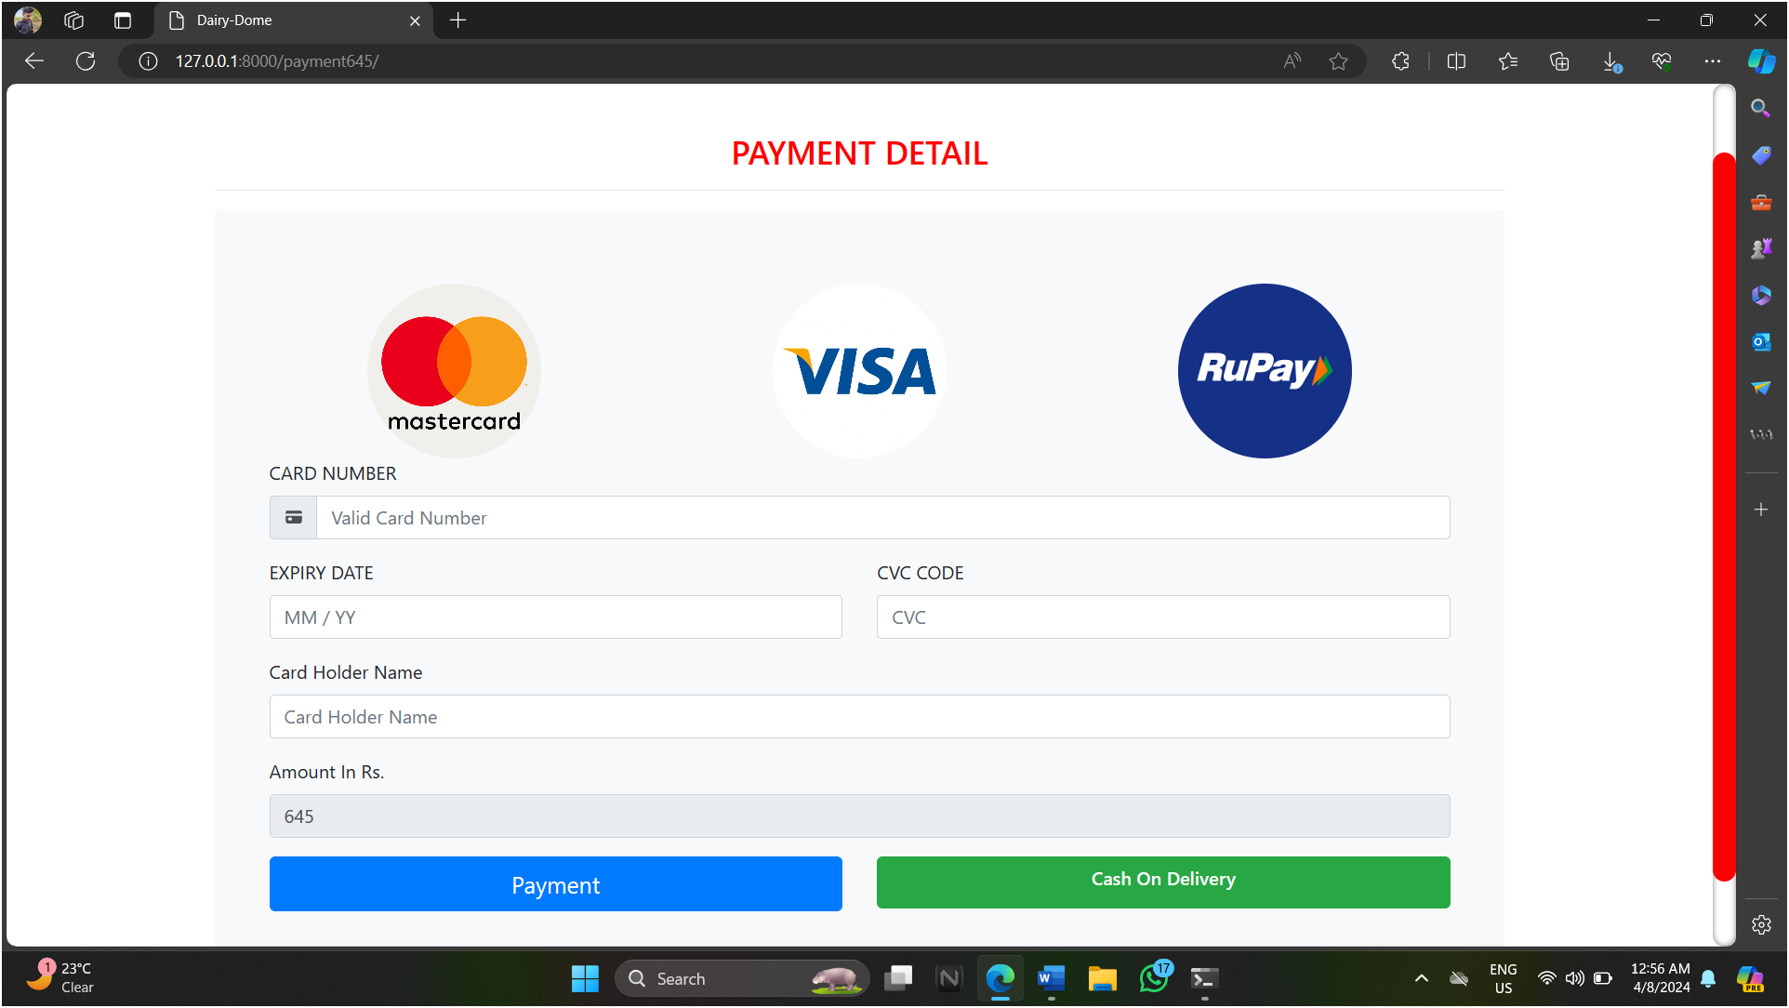

* View payment details